As Partial Fulfillment of:
MSc (IT) - Master of Science in Information Technology

Submitted To:

Atmiya Institute of Technology and Science – 2018

GUIDED BY: Prakash Gujarati
PREPARED BY: Dipen Parmar

A PROJECT REPORT ON
Restaurant Management System

DEVELOPED AT
ATMIYA UNIVERSITY
-------

FOR THE PARTIAL FULLFILLMENT OF THE REQUIREMENTS FOR THE
AWARD OF DEGREE IN

1th Semester
IN
MSc.IT & CA

SUBMITTED BY
Dipen Parmar

SUBMITTED TO


DEPARTMENT OF COMPUTER SCIENCE
ATMIYA UNIVERSITY, RAJKOT

Project Guide: PRAKASH GUJARATI

ACKNOWLEDGEMENT

I would like to highlight the fact that this project is the product of many contributors. First, I’d like to thank Professor Prakash Gujarati who accepted to work with me on my Project idea, supervising my work.

Second, I would like to thank the stack overflow community and Google for providing tremendous help to the elaboration of this project.

ABSTRAT

The Lara-POS Restaurant Management software is a capstone project that aims towards developing an all-in-one application that addresses the various problems and challenges faced by high-end restaurant owners today.

In order to achieve this goal, this project addresses various aspects of the modern Restaurant Management System in India.

All in all, this projects main aim is to reduce the time overhead in high-end management restaurants by providing an alternative to the traditional management system based on physical record keeping and paper work.

PROJECT PROFILE

PROJECT: | Lara-POS Restaurant Management.
OBJECTIVE:
INSTITUTE: | Atmiya Institute of Technology and Science
FRONT END: | Bootstrap 4, jQuery,
BACK END: | PHP 7.1.3 , Laravel 5.6 , MySql
DOCUMENTATION TOOL: | Ms-Word,Excel,Visio, Draw.io
DEVELOPED BY: | Dipen Parmar
GUIDED BY: | Prakash Gujarati
SUBMITTED TO: | M.Sc. IT & CA (AU)
- | https://wireframe.cc/IXI87W
-

INDEX

Sr | Particulars |  | PageNo
1 | Title Page |  | -
2 | ACKNOWLEDGEMENT |  | -
3 | ABSTRAT |  | -
4 | PROJECT PROFILE
5 | SYSTEM REQUIREMENTS (Hardware & Software) |  | -
 | 5.0 | Hardware
 | 5.1 | Software
6 | UML DIAGRAMS |  | ()
6 | 6.0 | Use Case | -
6 | 6.1 | Activity Diagram | -
6 | 6.2 | Wire Frame | -
6 | 6.3 | User Interface | -
6 | 6.4 | Data Dictionary | -
6 | 6.5 | Data Flow Diagram (DFD) | -
6 | 6.6 | E-R Diagram
7 | Report Softcopy |  | ()
8 | ---------------------------- |  | -
8 | 8.0 | Database Structure, Migrations | -
9 | Implementation |  | ()
9 | 9.0 | Errors and Solutions
9 | 9.1 | Challenging Tasks / Problems

HARDWARE REQUIREMENTS
Technical Details Hardware (Requirements)

Particulars | Hardware  Requirements
Processor Brand | Intel, Amd etc.
Processor Type | I3 Processor
Processor Speed | 1.5 GHz
RAM Size | 2 GB
Memory Type | DDR3
Hard Drive Size | 500 GB

Technical Details Software (Requirements)

Particulars | Software Requirements.
Operating System | Windows, Linux, Mac, any
Browser | • Chrome* 36+  • Edge* 20+  • Mozilla Firefox 31+

USE CASE

A use case describes how a user uses a system to accomplish a particular goal. A use case diagram consists of the system, the related use cases and actors and relates these to each other to visualize: what is being described? (system), who is using the system? (actors) and what do the actors want to achieve? (use cases), thus, use cases help ensure that the correct system is developed by capturing the requirements from the user's point of view.

----

What is a use case diagram?

In the Unified Modeling Language (UML), a use case diagram can summarize the details of your system's users (also known as actors) and their interactions with the system. To build one, you'll use a set of specialized symbols and connectors. An effective use case diagram can help your team discuss and represent:
- Scenarios in which your system or application interacts with people, organizations, or external systems
- Goals that your system or application helps those entities (known as actors) achieve
- The scope of your system
When to apply use case diagrams?

A use case diagram doesn't go into a lot of detail—for example, don't expect it to model the order in which steps are performed. Instead, a proper use case diagram depicts a high-level overview of the relationship between use cases, actors, and systems. Experts recommend that use case diagrams be used to supplement a more descriptive textual use case.

UML is the modeling toolkit that you can use to build your diagrams. Use cases are represented with a labeled oval shape. Stick figures represent actors in the process, and the actor's participation in the system is modeled with a line between the actor and use case. To depict the system boundary, draw a box around the use case itself.

UML use case diagrams are ideal for:
- Representing the goals of system-user interactions
- Defining and organizing functional requirements in a system
- Specifying the context and requirements of a system
- Modeling the basic flow of events in a use case
Use case diagram components
To answer the question, "What is a use case diagram?" you need to first understand its building blocks. Common components include:
Actors: The users that interact with a system. An actor can be a person, an organization, or an outside system that interacts with your application or system. They must be external objects that produce or consume data.
System: A specific sequence of actions and interactions between actors and the system. A system may also be referred to as a scenario.
Goals: The end result of most use cases. A successful diagram should describe the activities and variants used to reach the goal.

Use case diagram symbols and notation
The notation for a use case diagram is pretty straightforward and doesn't involve as many types of symbols as other UML diagrams.
- Use cases: Horizontally shaped ovals that represent the different uses that a user might have.
- Actors: Stick figures that represent the people actually employing the use cases.
- Associations: A line between actors and use cases. In complex diagrams, it is important to know which actors are associated with which use cases.
- System boundary boxes: A box that sets a system scope to use cases. All use cases outside the box would be considered outside the scope of that system. For example, Psycho Killer is outside the scope of occupations in the chainsaw example found below.

System:
Draw your system's boundaries using a rectangle that contains use cases. Place actors outside the system's boundaries.
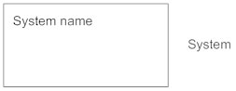
Use Case:
Draw use cases using ovals. Label the ovals with verbs that represent the system's functions.
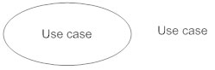
Actors:
Actors are the users of a system. When one system is the actor of another system, label the actor system with the actor stereotype.
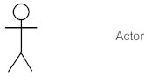
Relationships:
Illustrate relationships between an actor and a use case with a simple line. For relationships among use cases, use arrows labeled either "uses" or "extends." A "uses" relationship indicates that one use case is needed by another in order to perform a task. An "extends" relationship indicates alternative options under a certain use case.
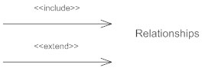

Src 1: https://www.lucidchart.com/pages/uml-use-case-diagram
Src 2: https://www.smartdraw.com/use-case-diagram/
- Use case diagram for Restaurant management system:
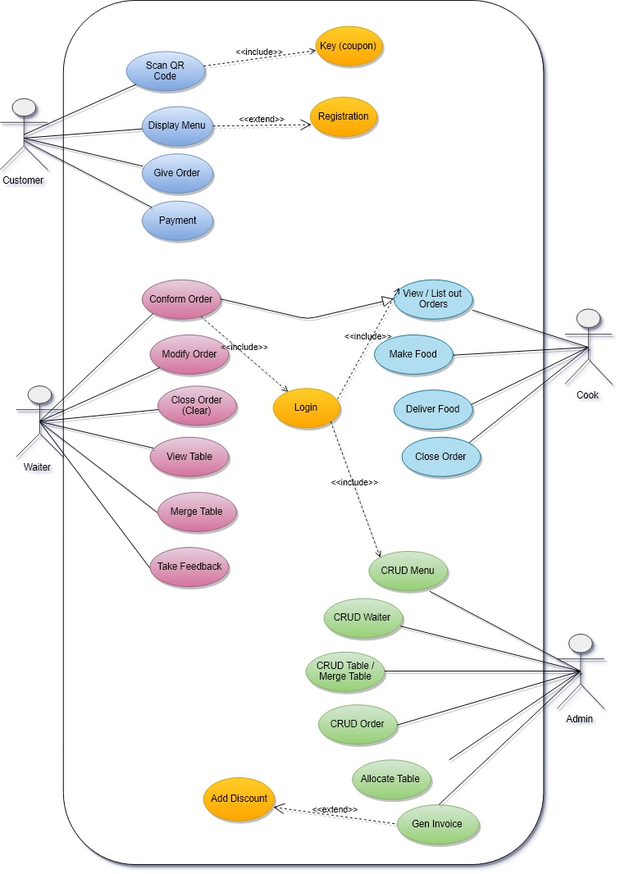
Drawing Tool Used- : Draw.io
Draw.io is free online diagram software for making flowcharts, process diagrams, org charts, UML, ER and network diagrams.
Website: https://www.draw.io/

ACTIVITY DIAGRAM
Activity diagram: is another important behavioral diagram in UML diagram to describe dynamic aspects of the system. Activity diagram is essentially an advanced version of flow chart that modeling the flow from one activity to another activity.

When to Use Activity Diagram?
Activity Diagrams describe how activities are coordinated to provide a service which can be at different levels of abstraction. Typically, an event needs to be achieved by some operations, particularly where the operation is intended to achieve a number of different things that require coordination, or how the events in a single use case relate to one another, in particular, use cases where activities may overlap and require coordination. It is also suitable for modeling how a collection of use cases coordinate to represent business workflows
- Identify candidate use cases, through the examination of business workflows
- Identify pre- and post-conditions (the context) for use cases
- Model workflows between/within use cases
- Model complex workflows in operations on objects
- Model in detail complex activities in a high level activity Diagram

- Activity Diagram Notation Summary
Symbol | Name | Description
 | Start symbol | Represents the beginning of a process or workflow in an activity diagram. It can be used by itself or with a note symbol that explains the starting point.
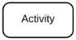 | Activity symbol | Indicates the activities that make up a modeled process. These symbols, which include short descriptions within the shape, are the main building blocks of an activity diagram.
 | Connector symbol | Shows the directional flow, or control flow, of the activity. An incoming arrow starts a step of an activity; once the step is completed, the flow continues with the outgoing arrow.
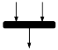 | Joint symbol/ Synchronization bar | Combines two concurrent activities and re-introduces them to a flow where only one activity occurs at a time. Represented with a thick vertical or horizontal line.
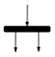 | Fork symbol | Splits a single activity flow into two concurrent activities. Symbolized with multiple arrowed lines from a join.
 | Decision symbol | Represents a decision and always has at least two paths branching out with condition text to allow users to view options. This symbol represents the branching or merging of various flows with the symbol acting as a frame or container.
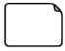 | Note symbol | Allows the diagram creators or collaborators to communicate additional messages that don't fit within the diagram itself. Leave notes for added clarity and specification.
 | Flow final symbol | Represents the end of a specific process flow. This symbol shouldn’t represent the end of all flows in an activity; in that instance, you would use the end symbol. The flow final symbol should be placed at the end of a process in a single activity flow.
 | End symbol | Marks the end state of an activity and represents the completion of all flows of a process.
Src 1: https://www.lucidchart.com/pages/uml-activity-diagram

Src 2: https://online.visual-paradigm.com/tutorials/activity-diagram-tutorial/

Src 3: https://www.lucidchart.com/pages/uml-activity-diagram

- Activity Diagram For Customer

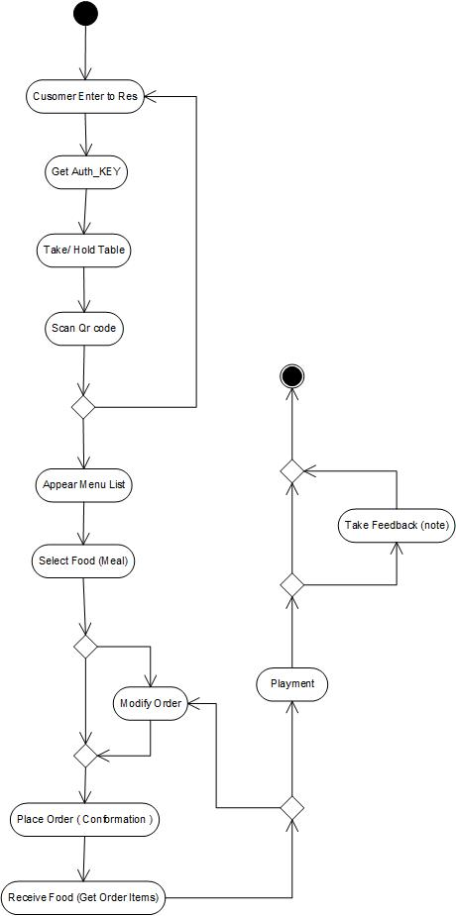

- Activity Diagram For Waiter

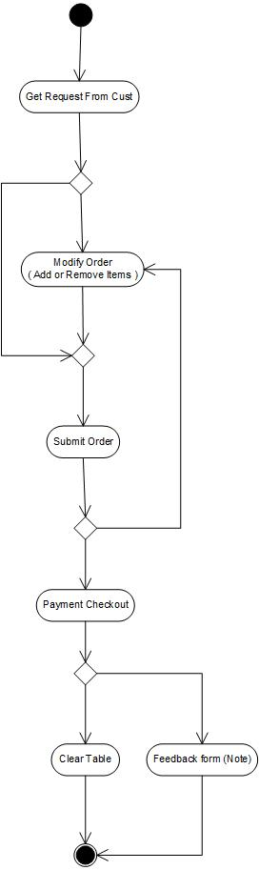

- Activity Diagram For Cook

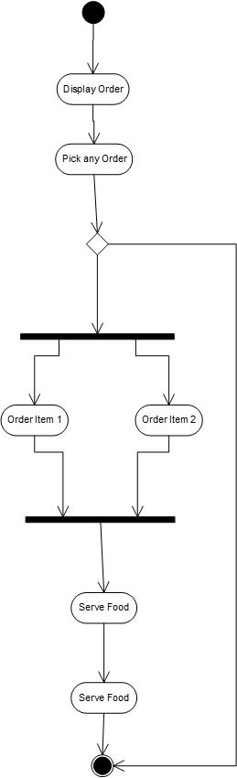

WIRE FRAME
- Main Page

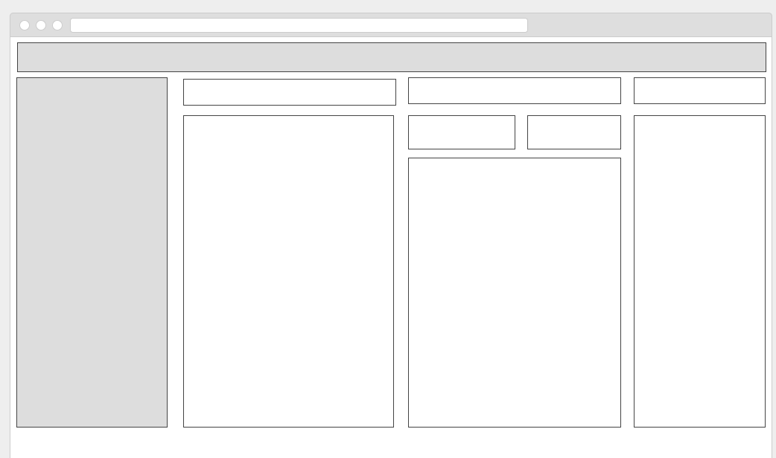
Active Table
Select Table
Item Category DropDown
SubCate
Search Item
Main Header
Logo, Name
Main Sidebar

Link 1
Link 2

Link 3
Link 4
Link 5

Table list

T1 T2

T3 T4

Sr. | Item Name| Qty |
Order Cart Table
Select Item
Add Item in order List
- Item view ( Table ) page
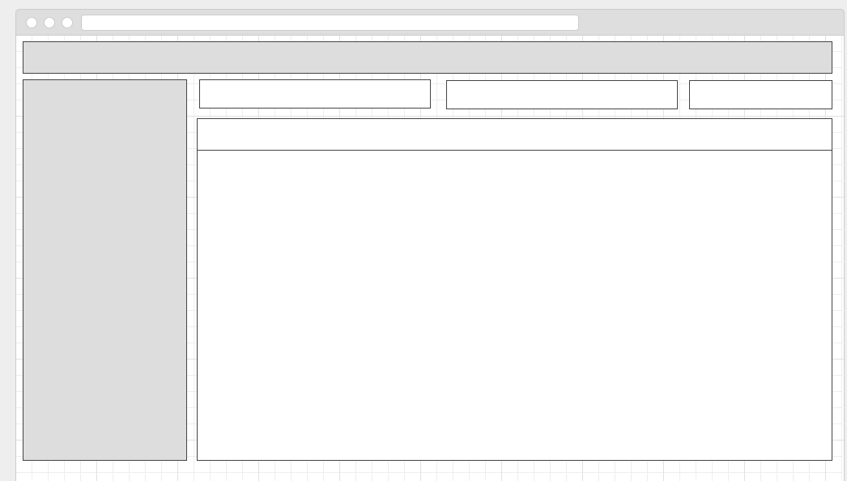
Items
Add_Btn
Item Table
Sr. | Item Name | ItemDescription | Edit Btn | Delete Btn
- Item Edit and Update Model page

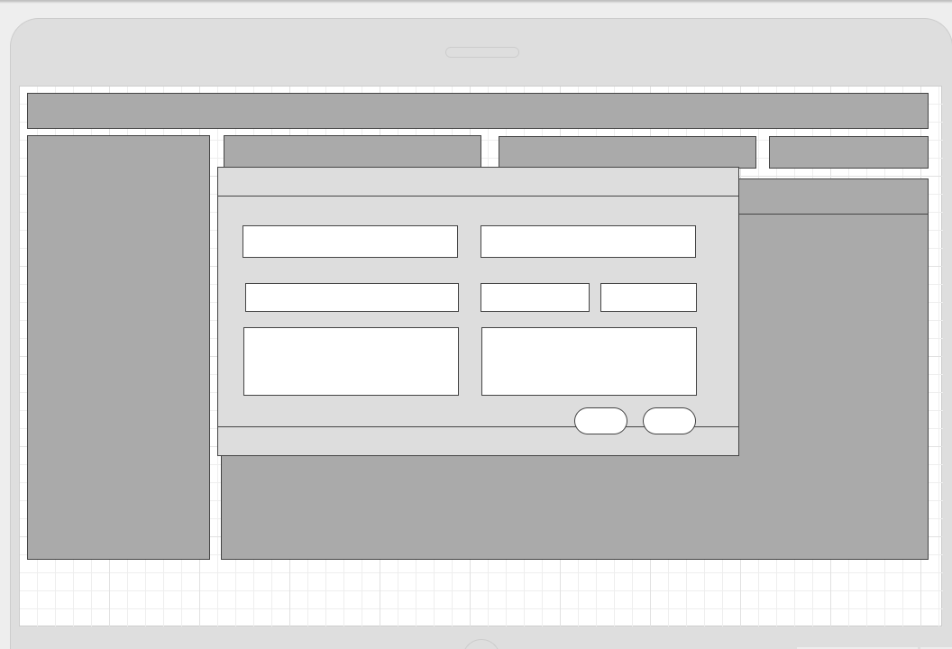

USER INTERFACE
What is User Interface Design?

User Interface (UI) Design is the link between users and your website. It includes the basic design elements that need to be present in order to for someone to navigate your site and make decisions. It is the ever-evolving relationship between a person and the system that they are using. It includes the way that your website interacts with users, the overall design and how information is presented.

There are many different ways that you can look at user interface, but the basics always include the communication from a product to the user and vice versa1.

UI Design is all about structure, user manipulation and communication. This is one of the reasons it’s so important that you pay close attention to it. It is the basic building blocks of how your website is set up and functions when visited by your target audience. If it doesn’t go smoothly, problems tend to follow.

Some of the elements involved in User Interface Design include the input controls, navigational components, informational components and containers4. The devil is in the details, as they say. Buttons, lists, toggles, icons, breadcrumbs, tags and more also play a huge role. It is the way that you design your site from the back-end so that your audience can have a seamless, and enjoyable, front-end experience.

There are 3 issues / parts of a user interface design, these being
- how it looks,
- how it works,
- how easy it is to use.

Key Components of UI/UX Design
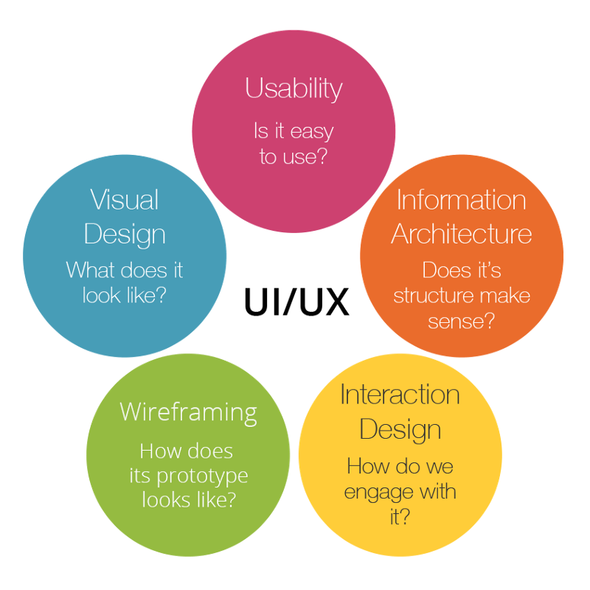
There are some core components of UX Design, which are as follows:
- Information Architecture
- Interaction Design
- Usability
- Wire framing
- Visual Design

Src: https://techterms.com/definition/user_interface

Interaction Design
Interaction Design is about creating the conceptual design with which the users interact with the product and/or application. This interaction includes various elements such as aesthetics, color, font, icons, images, motion, sound, space, graphics etc.
Usability
Usability can be referred as the user-friendliness as well. Along with figuring out if the users get the information they want by using the application or visiting the site for the first time and if the application/website is easy to navigate, the usability also comprehends the ways to handle the errors.
Wire framing
Wire framing is about creating a sample of the application to test the features, look and usability of the application before it is actually launched. It is a cheap way to test functionality and evaluate if the application serves the purpose.
Visual Design
Visual design of the application or the website is like defining the company’s brand. Finalizing the visual design can affect the users’ behavior and hence it is the most important component of the UI design. Visual Design is not only about selecting the best images, colors, icons, fonts, but also identifying the appearance of the application impacts the interaction of its users. Now that you are aware with the UI/UX components, we would like to tell you how this whole procedure actually works.

Src: https://medium.com/@thinkwik/do-you-know-the-importance-of-ui-ux-development-773eae38436e

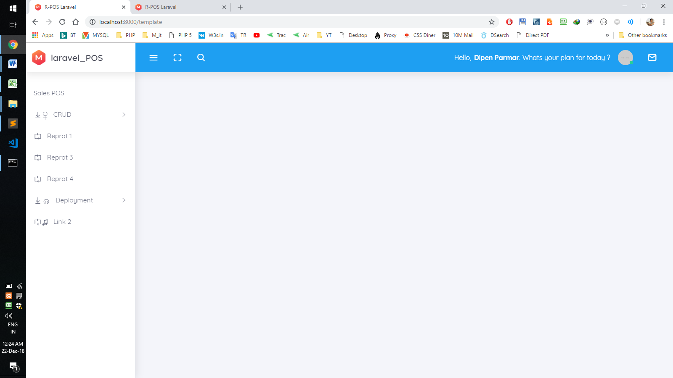
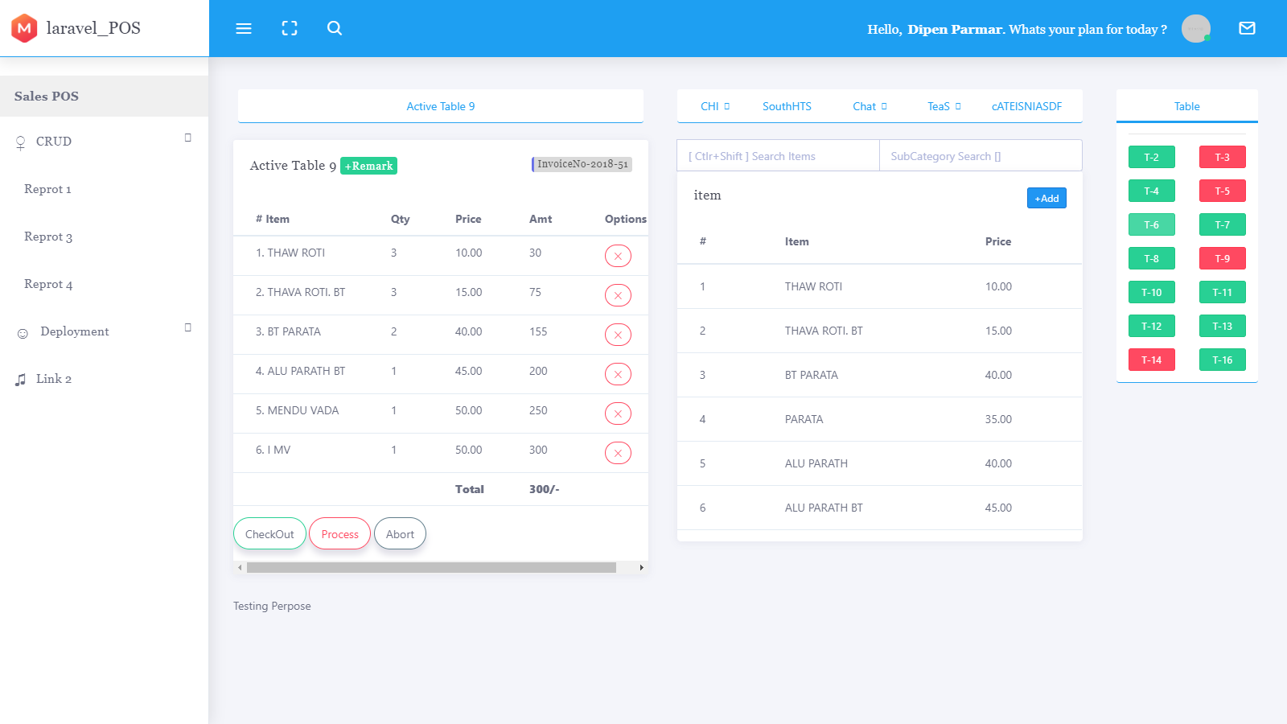

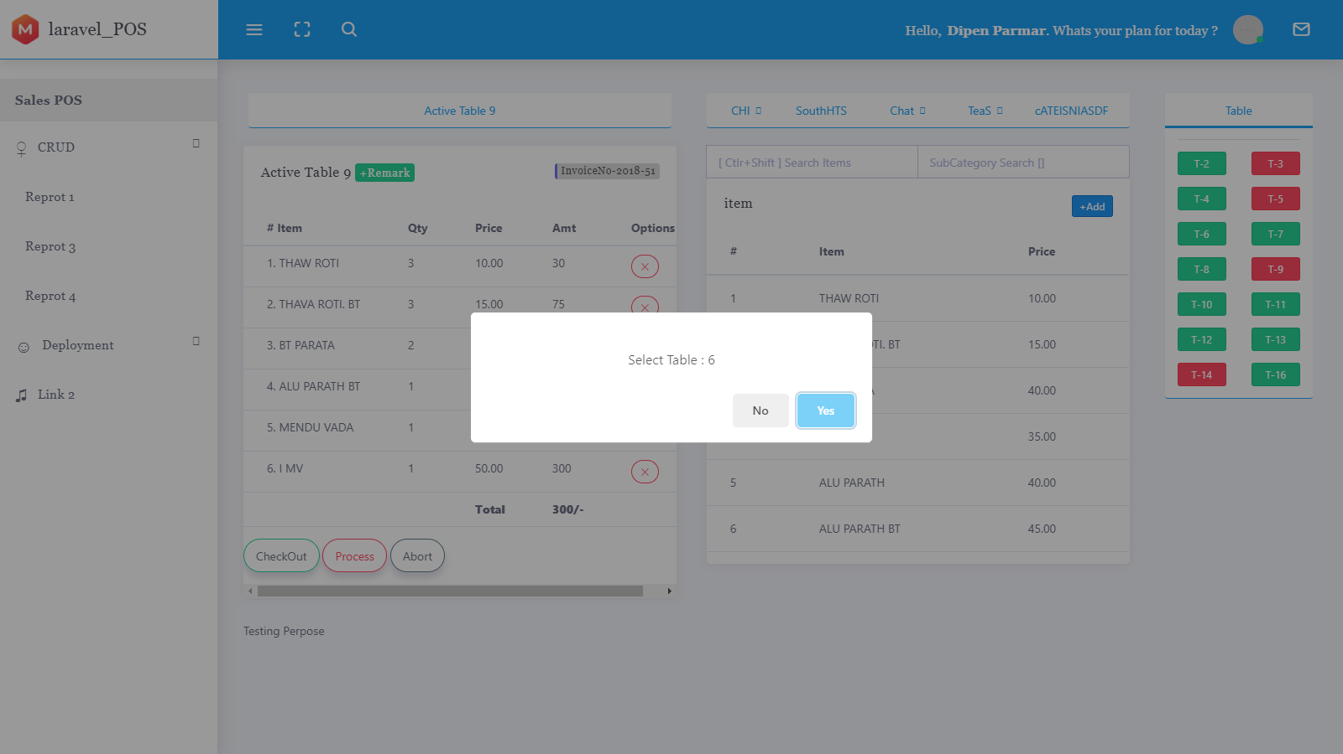
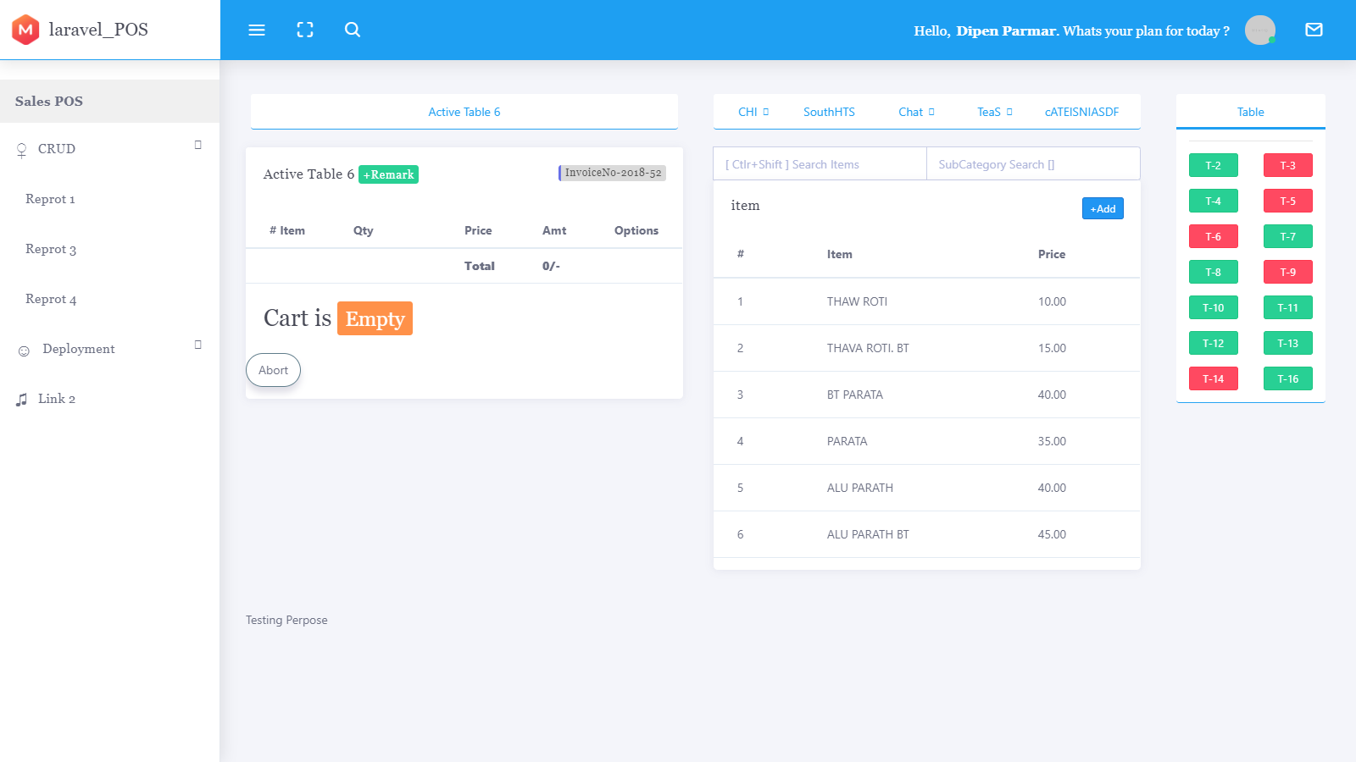

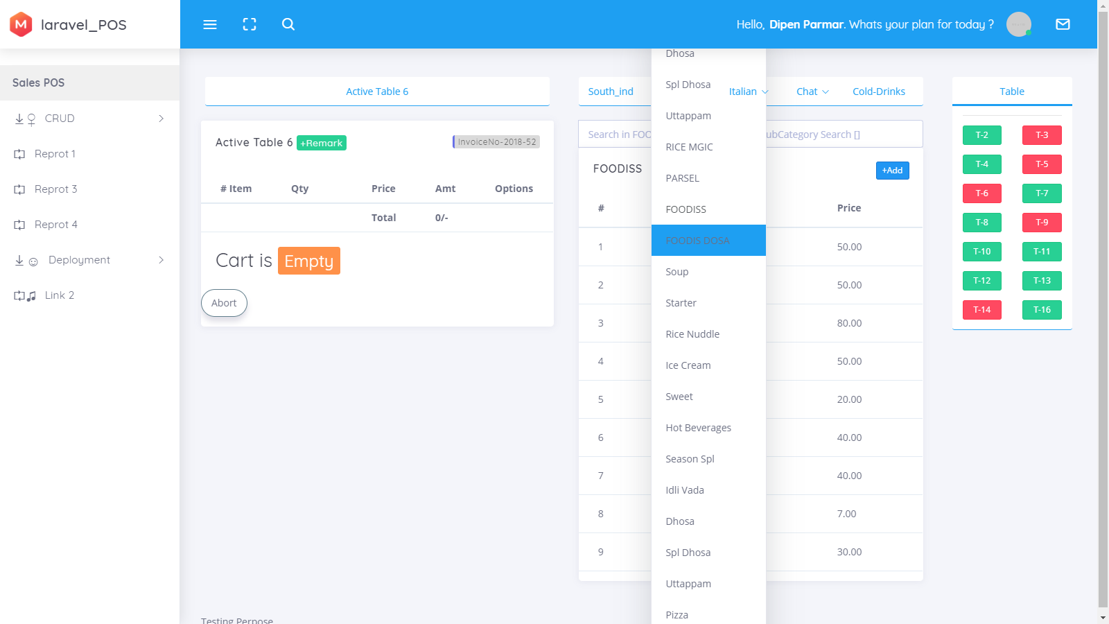
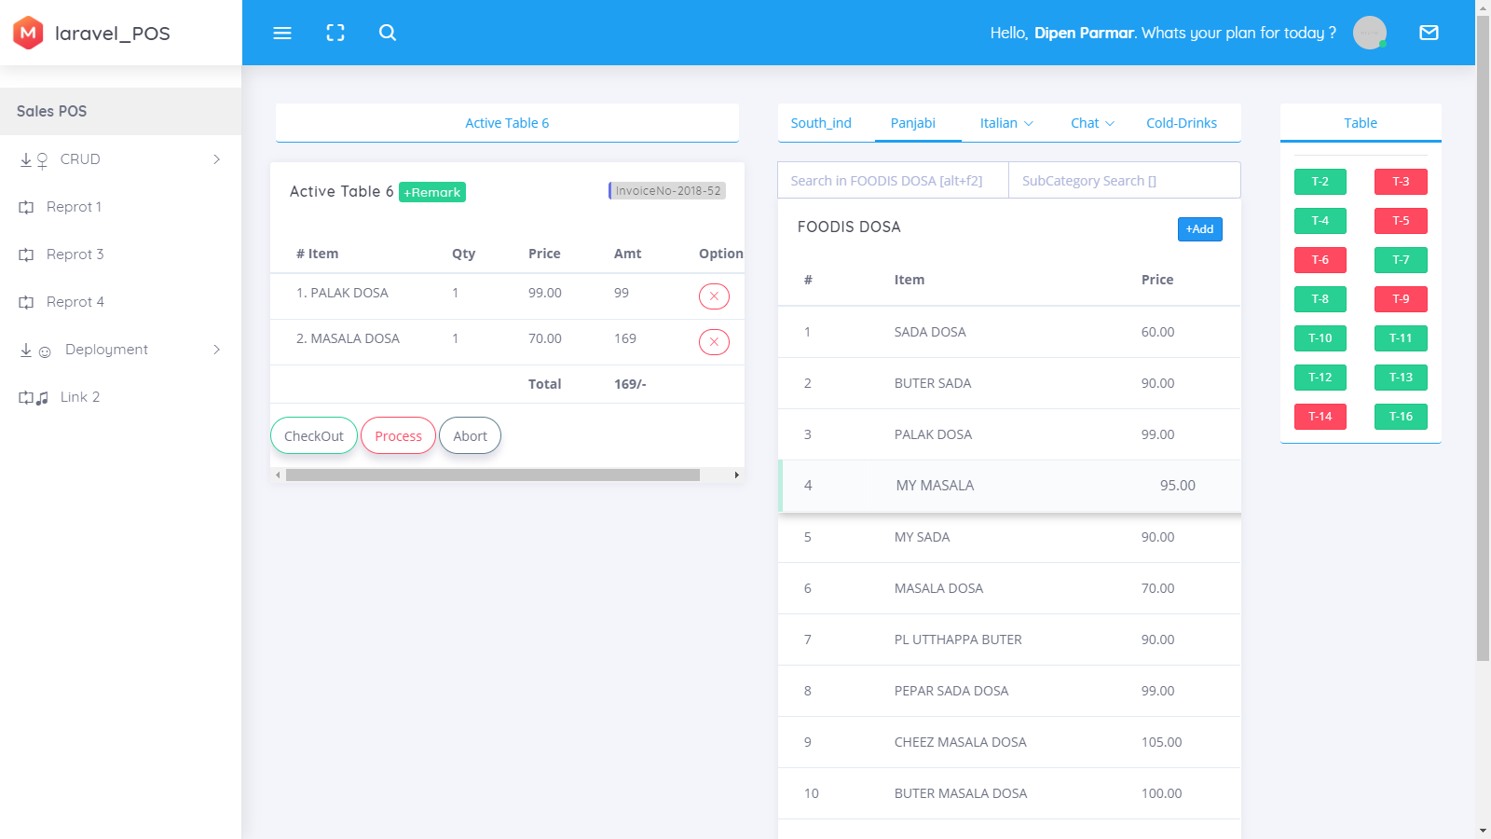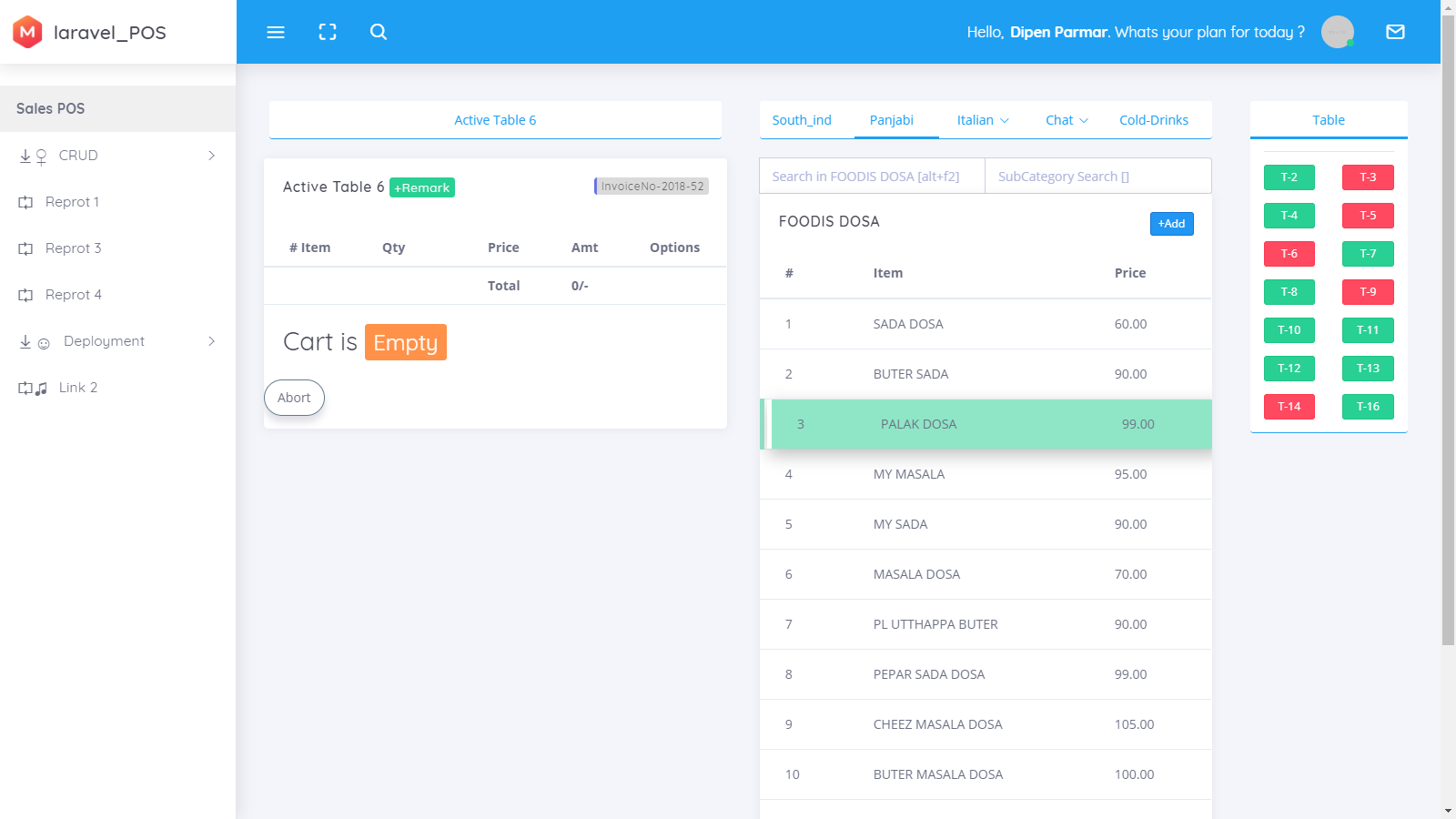
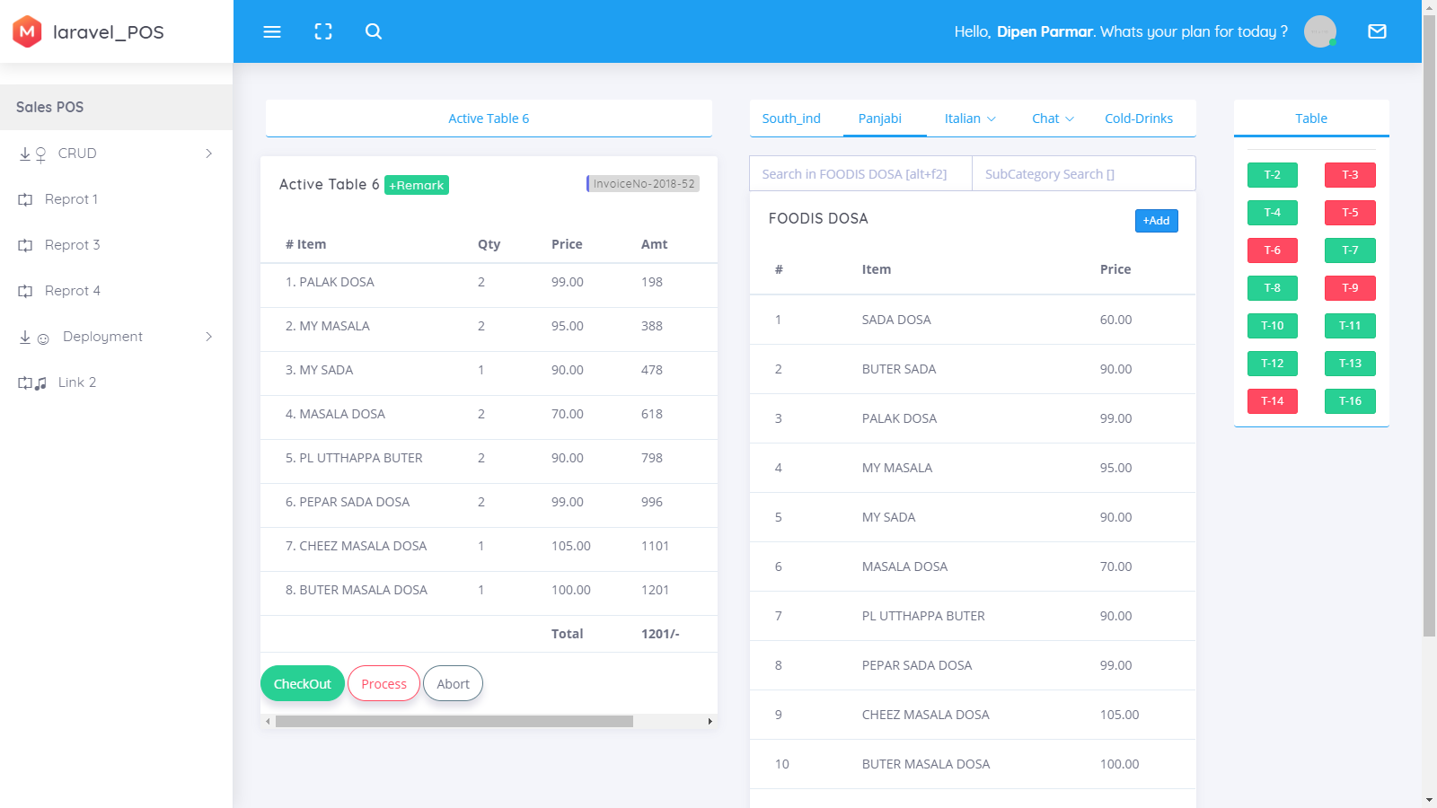

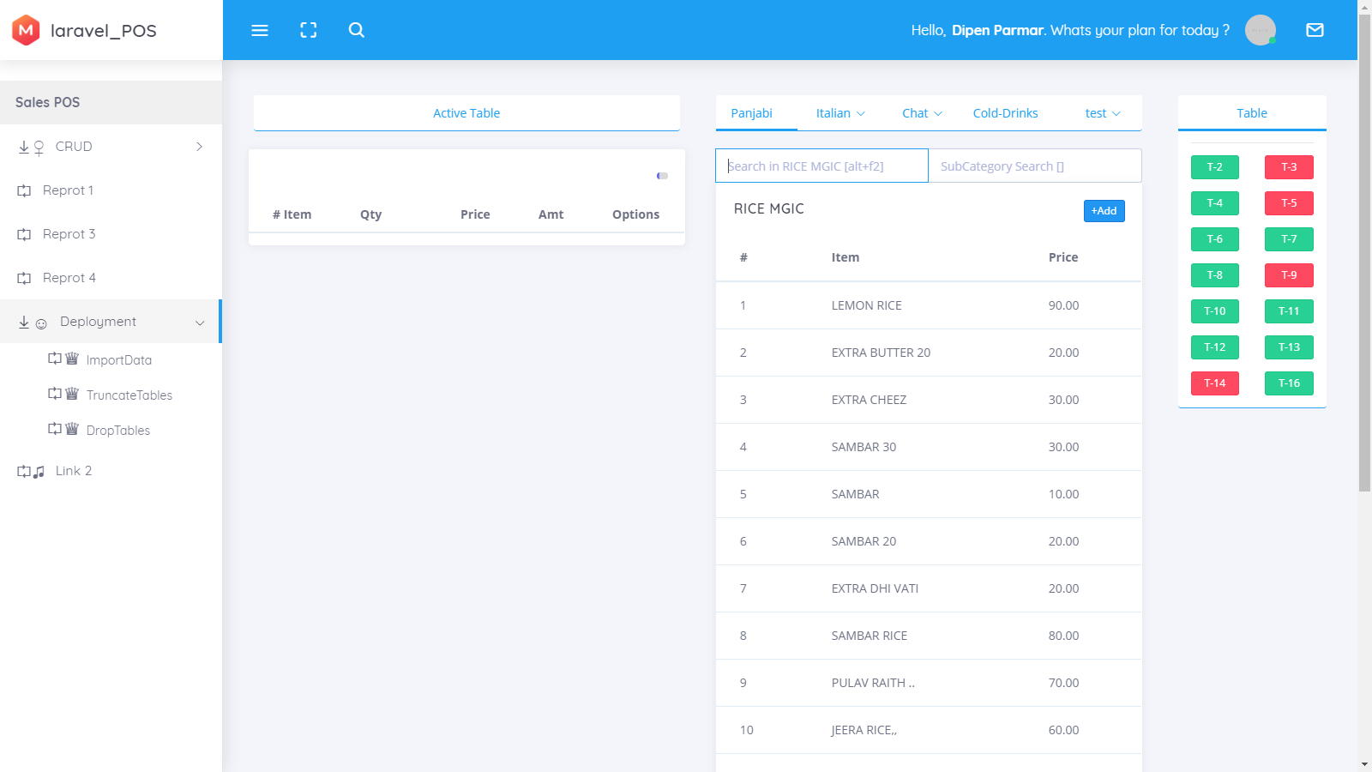

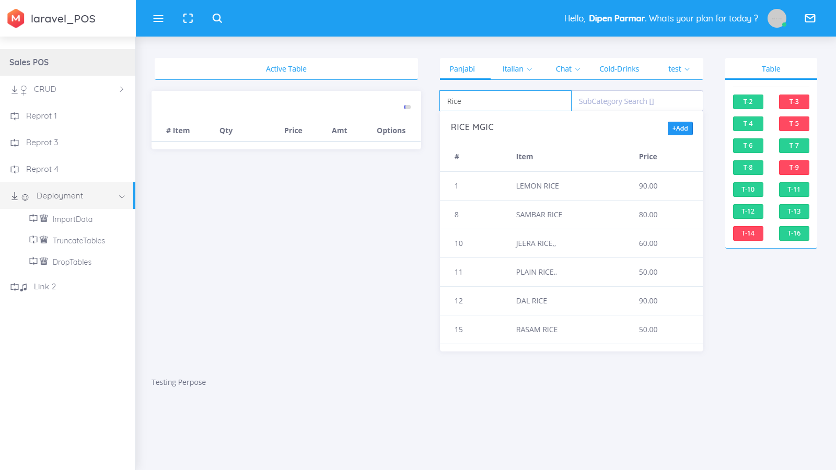

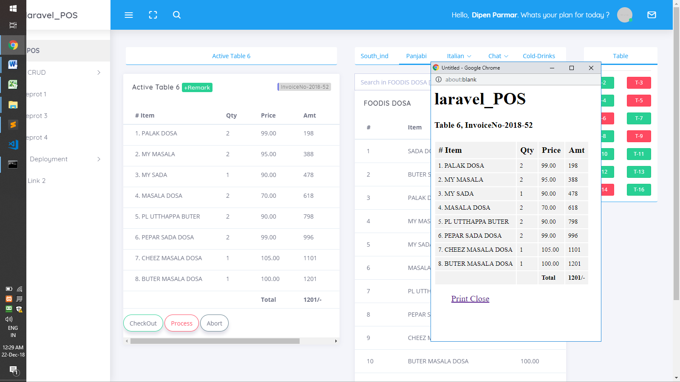
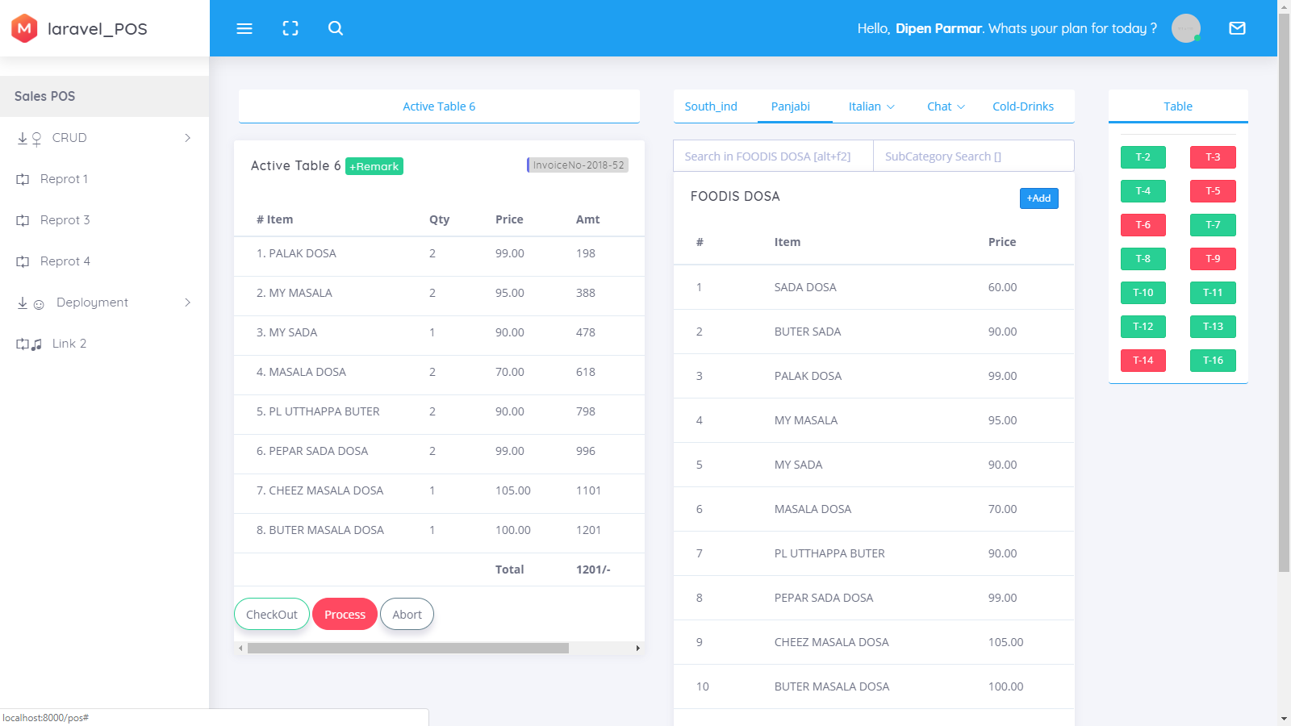
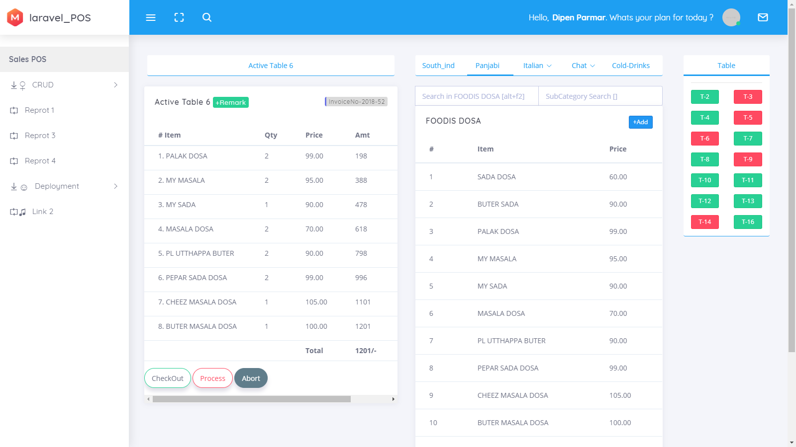
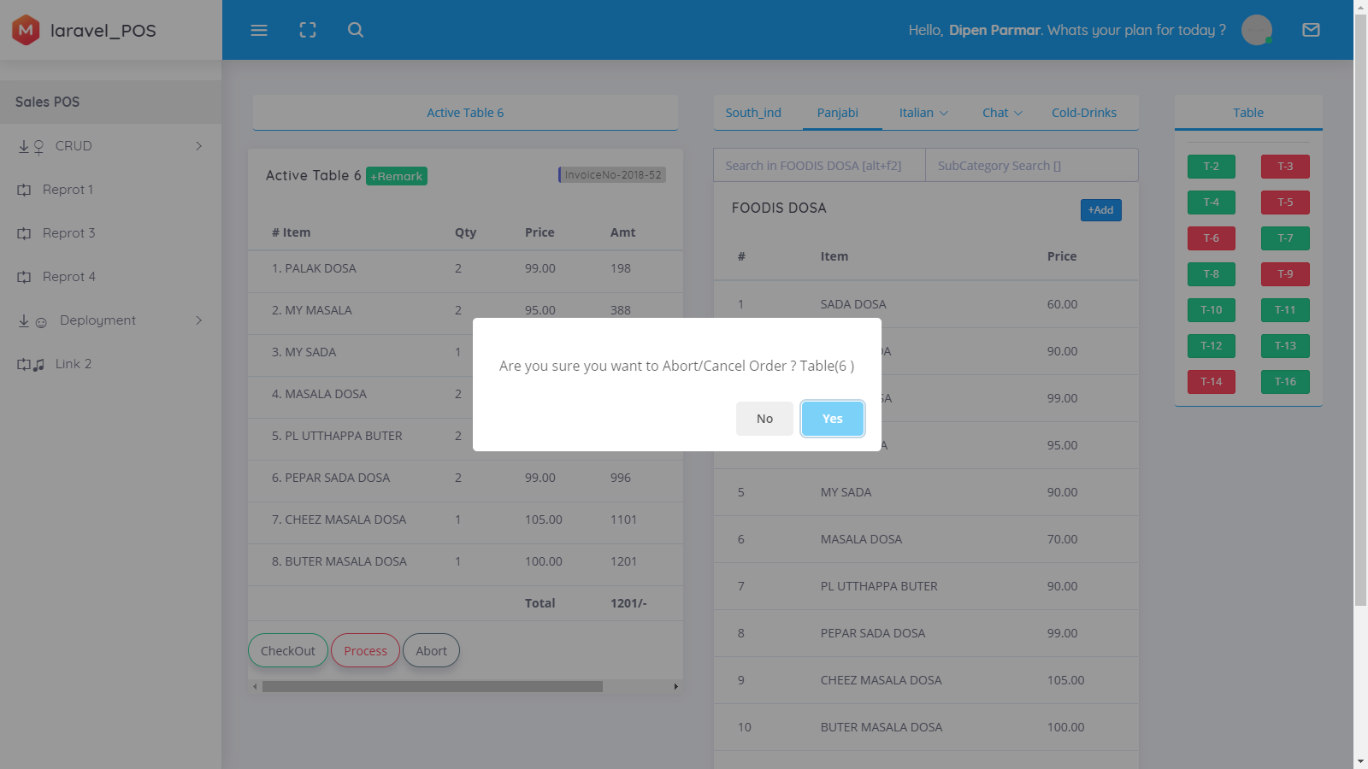

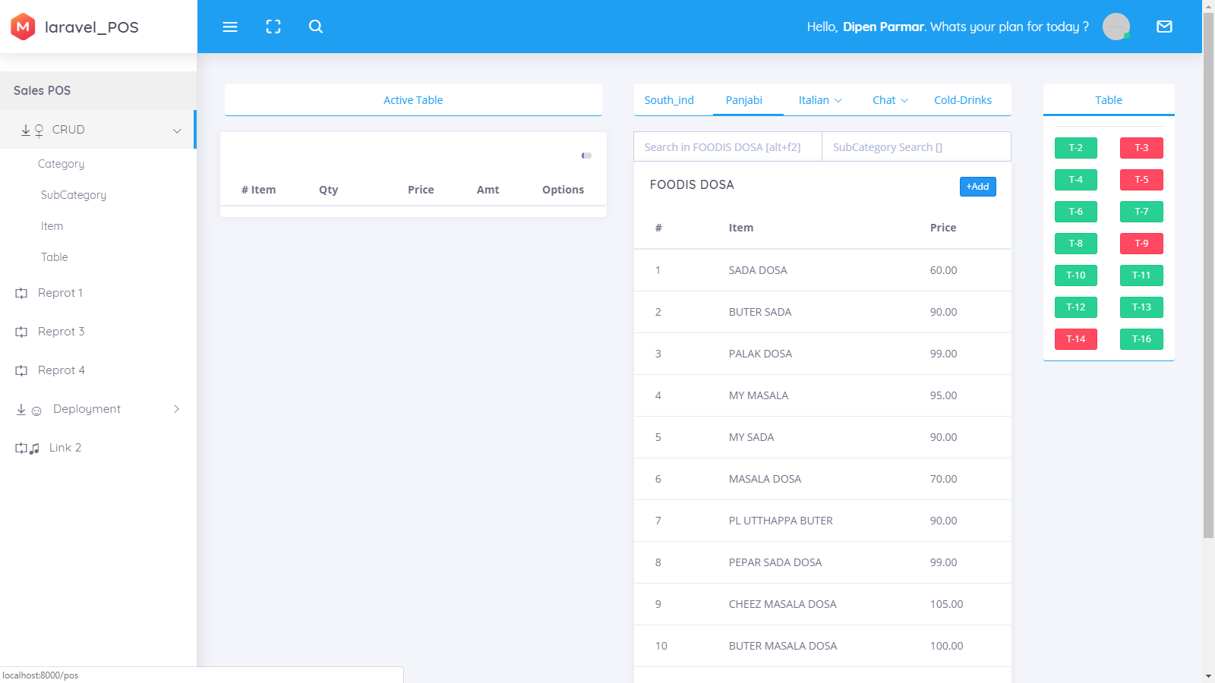

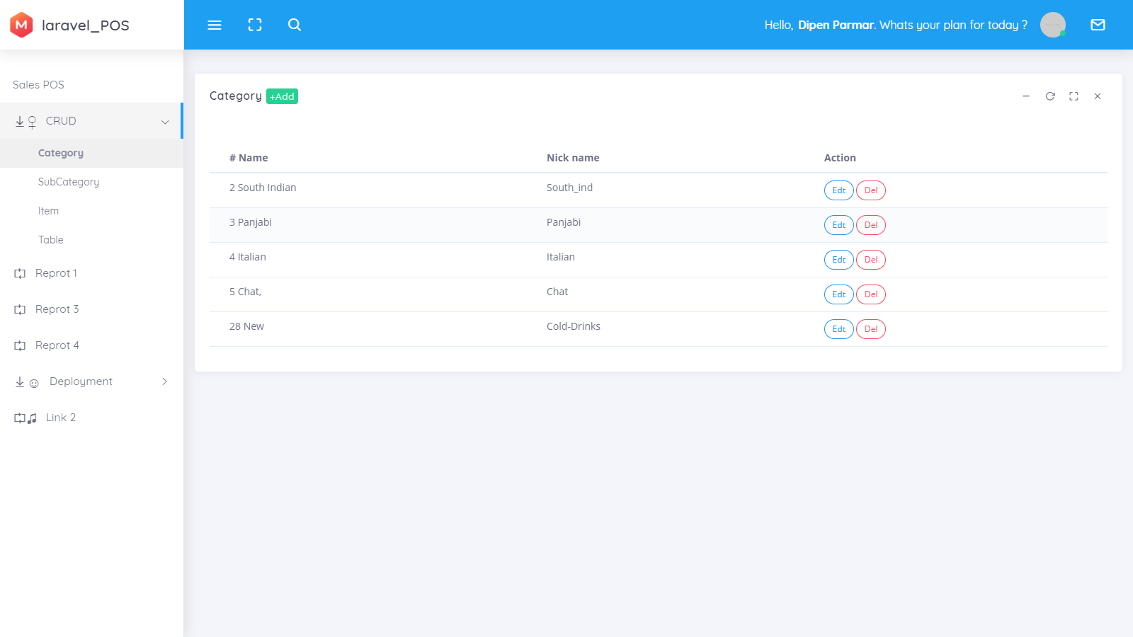
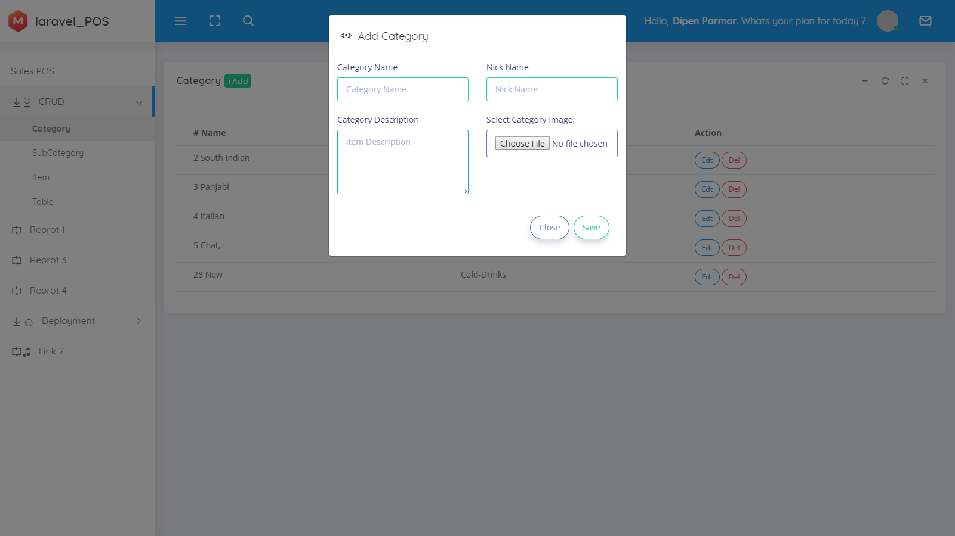

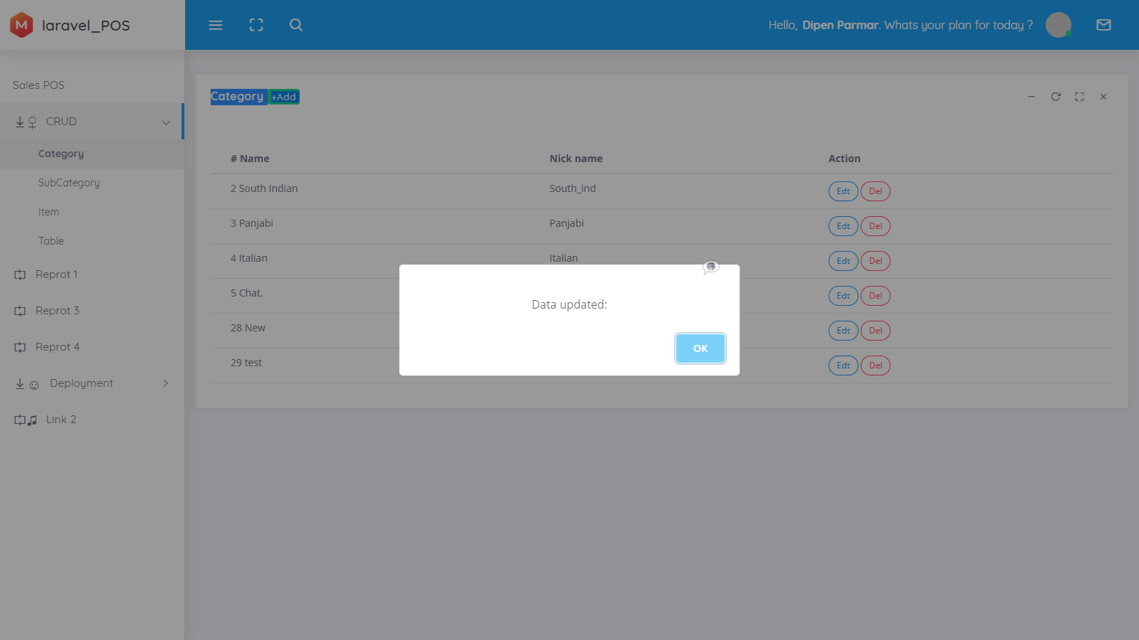
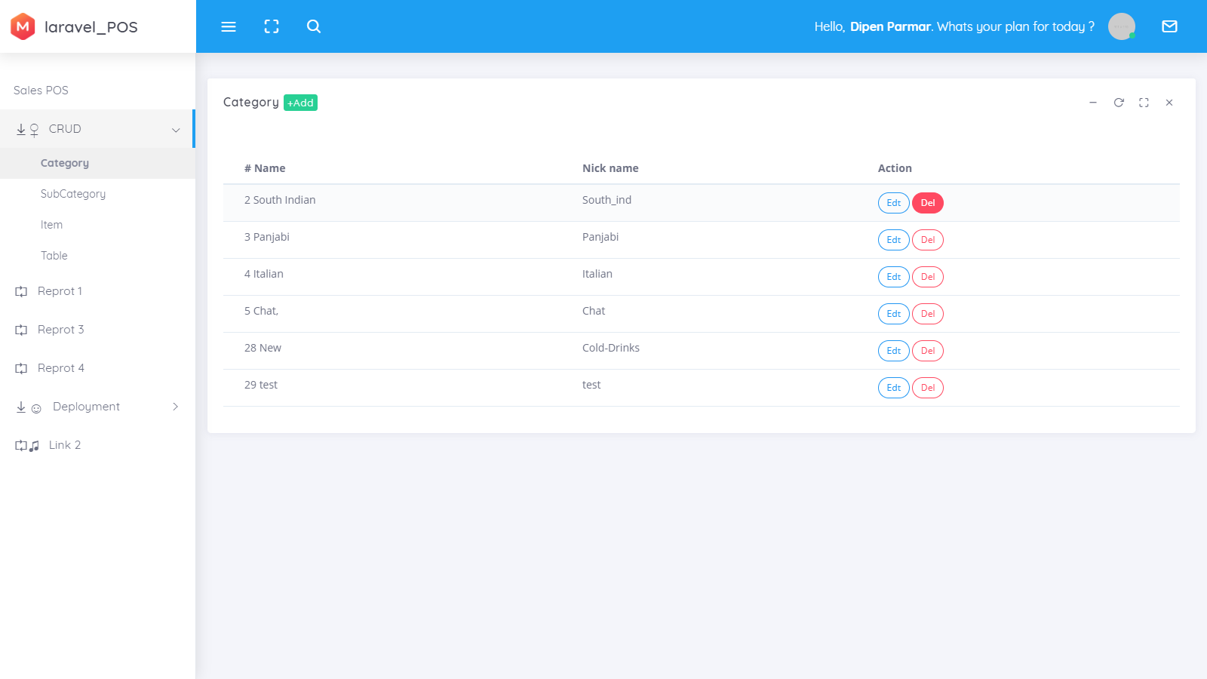

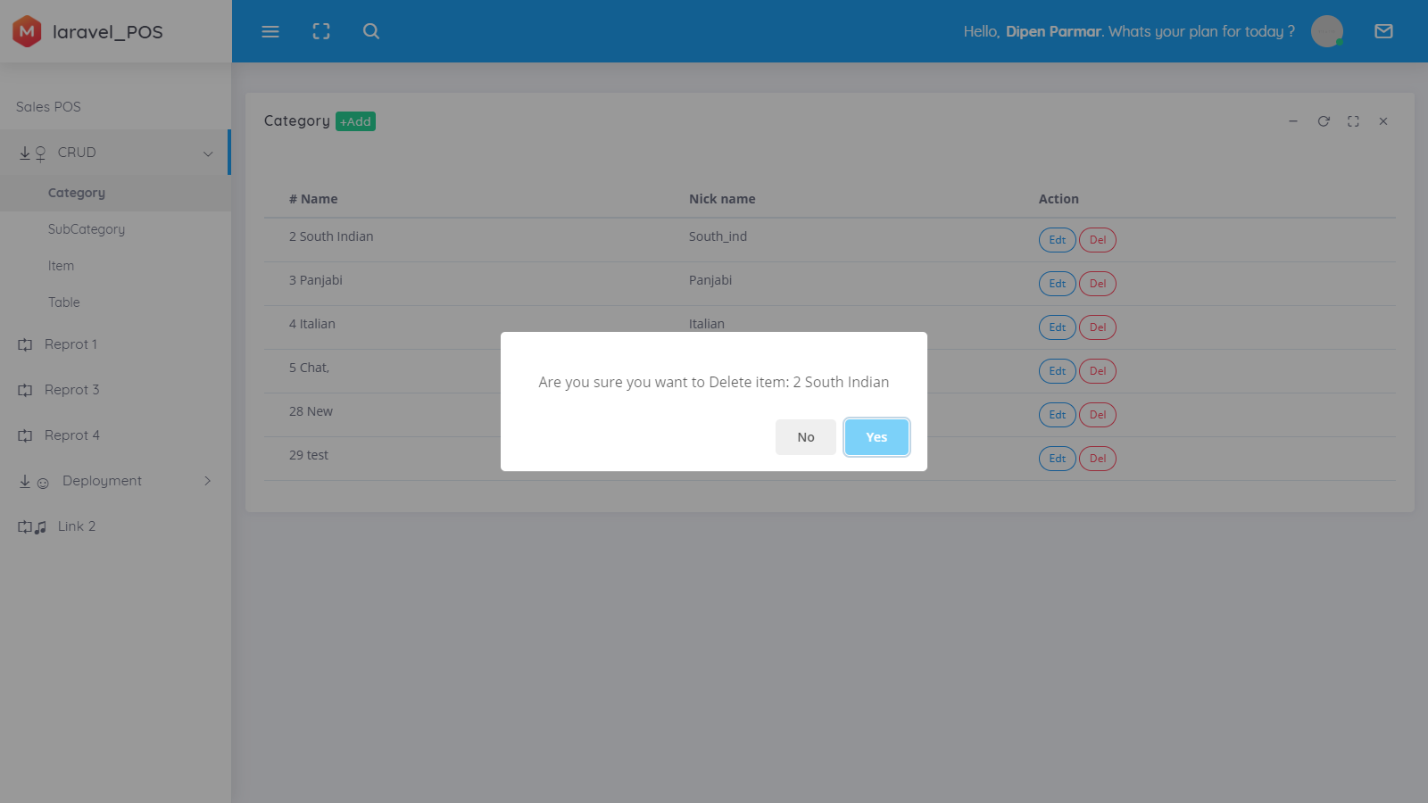

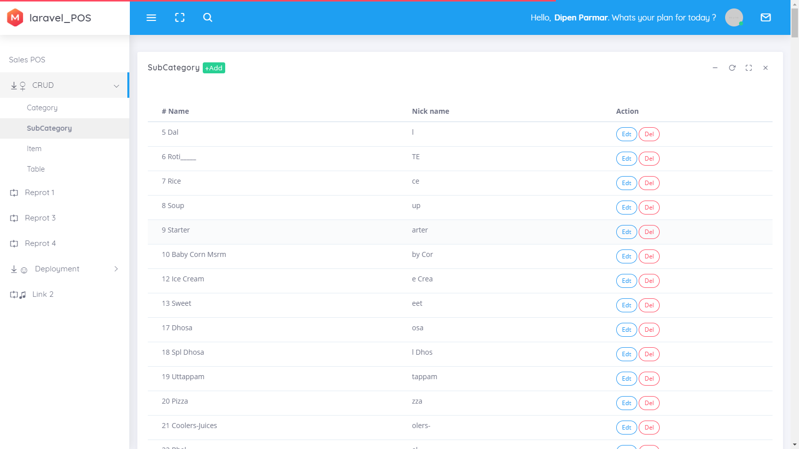

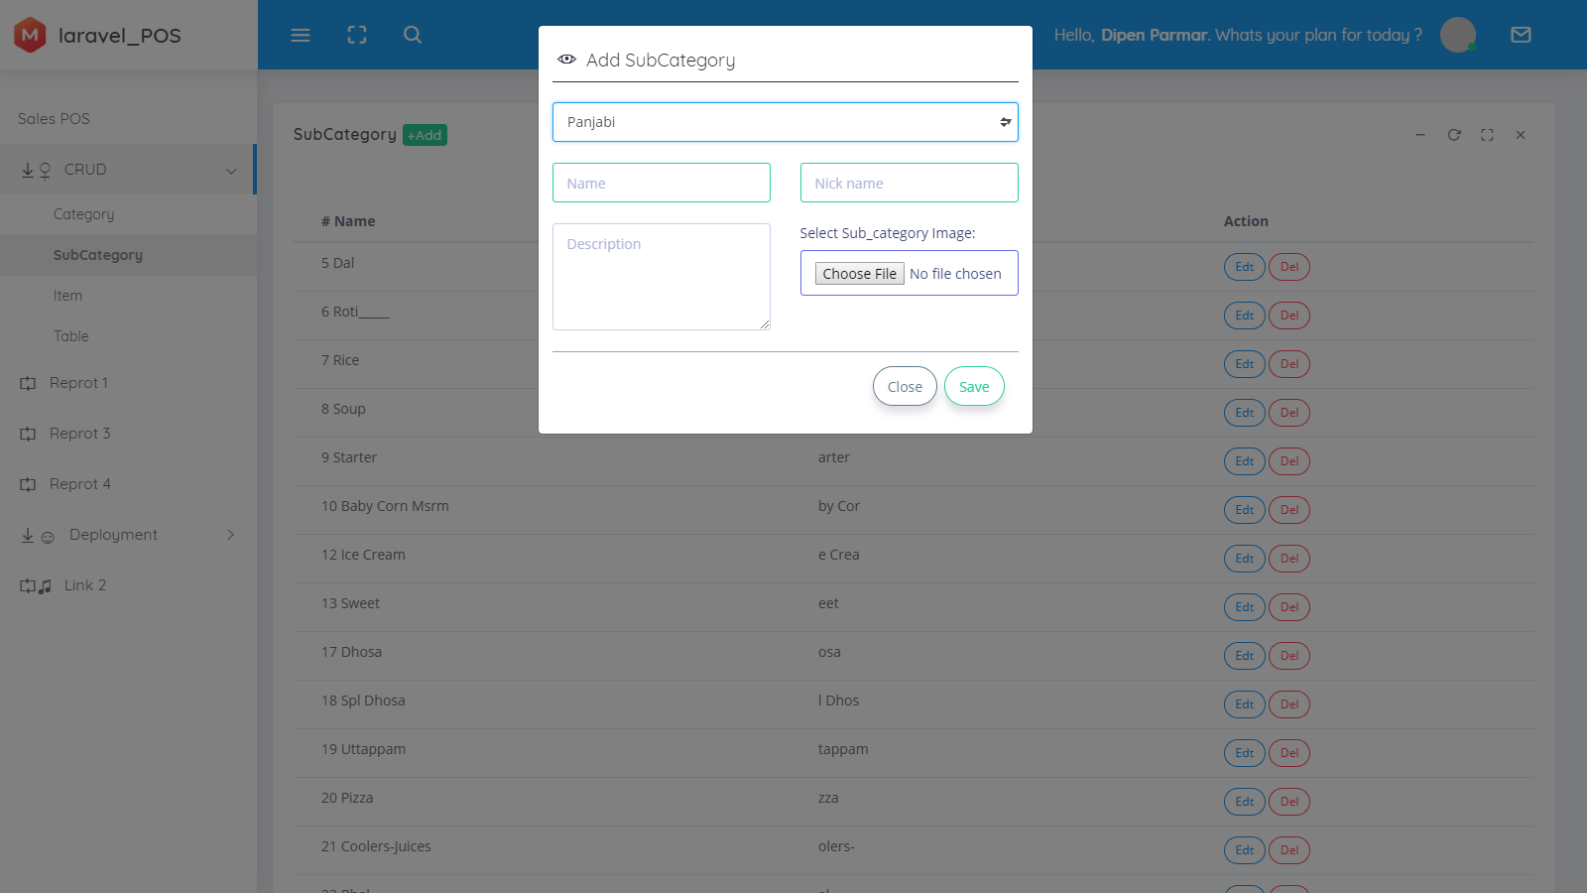
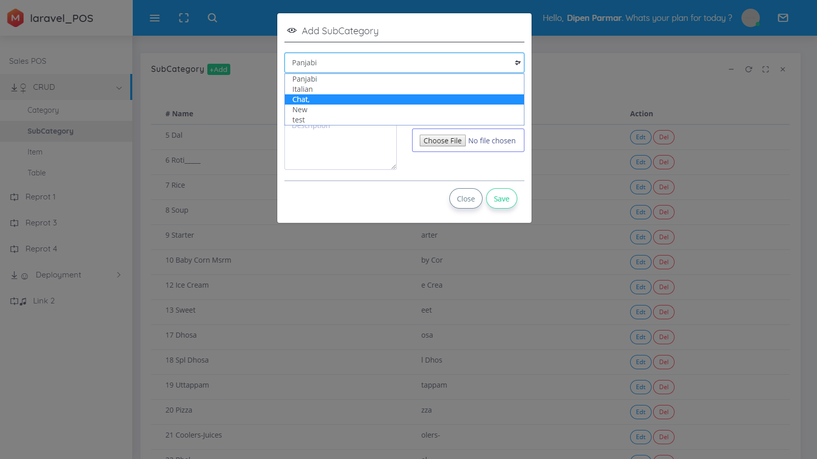

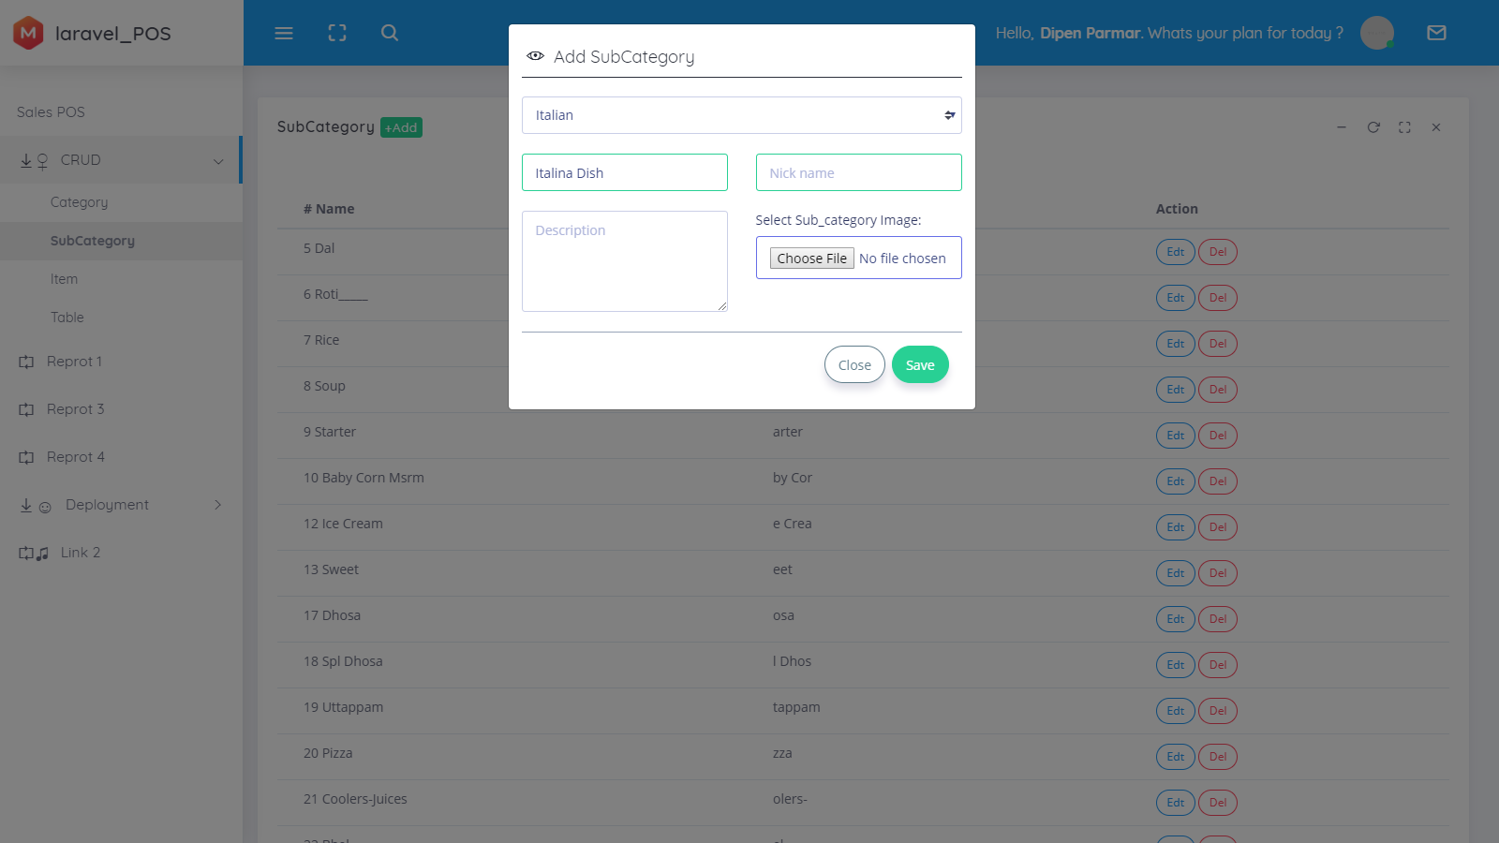

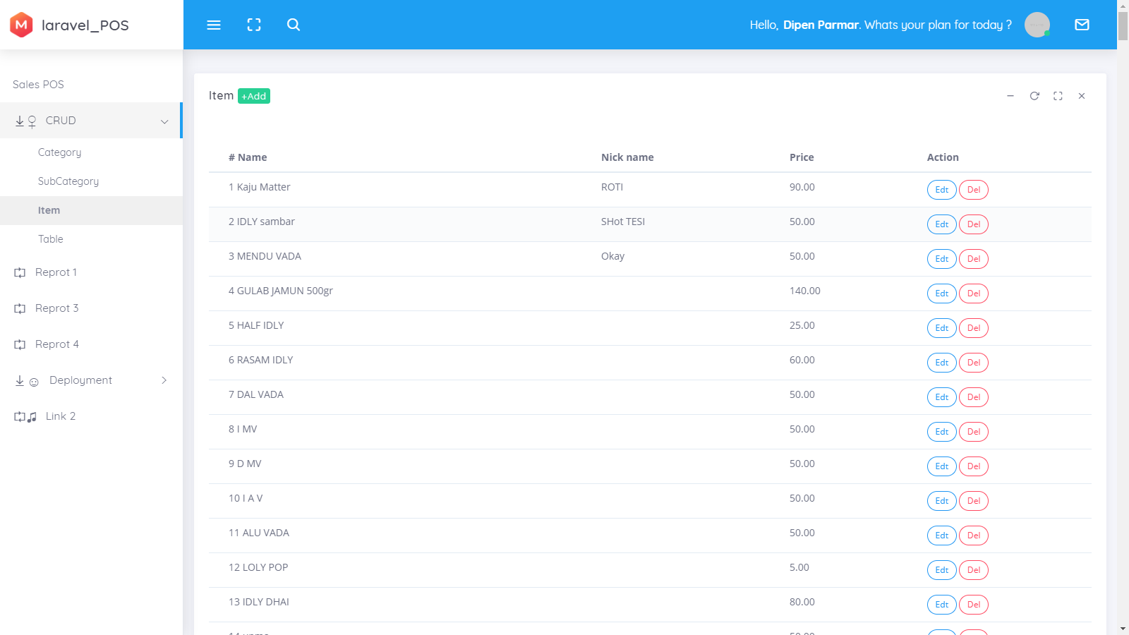

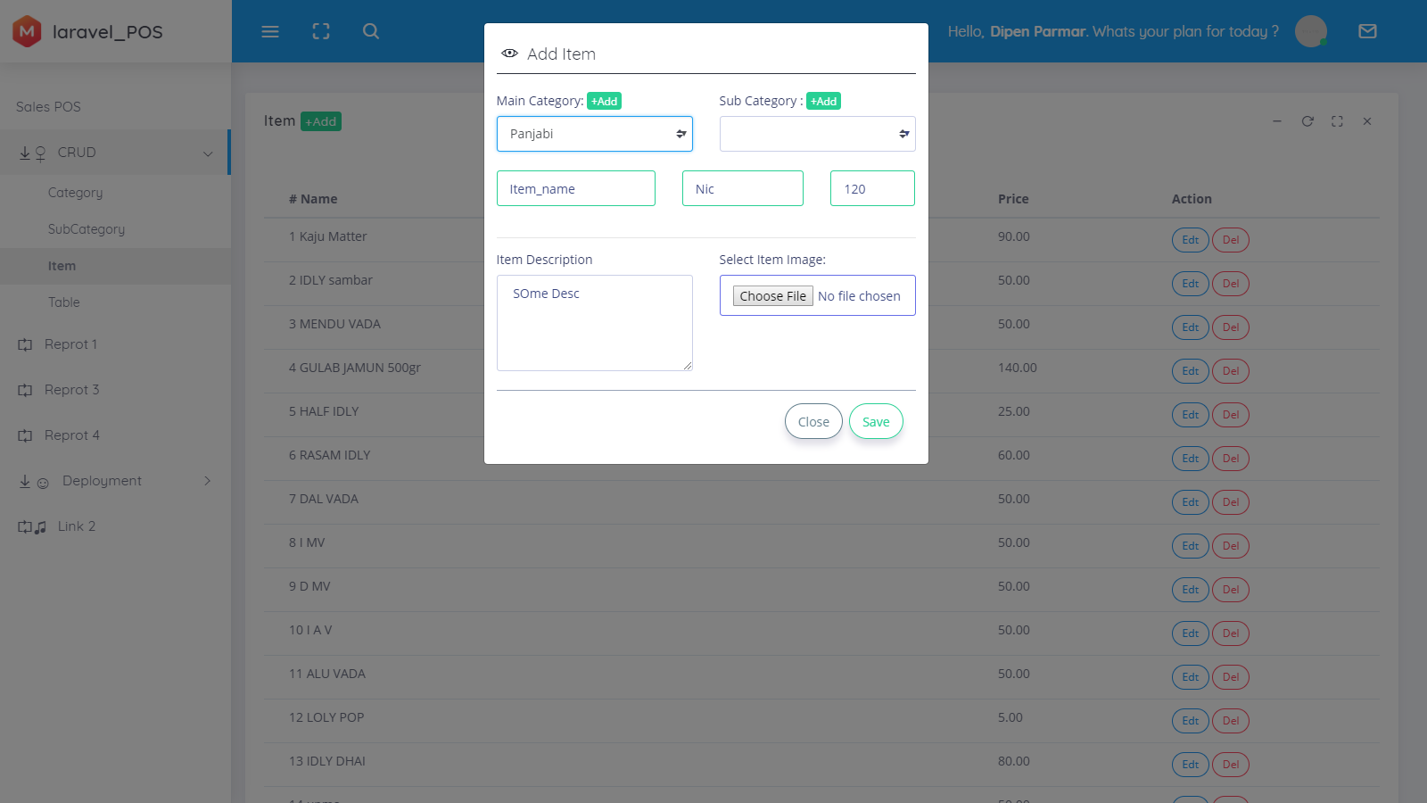

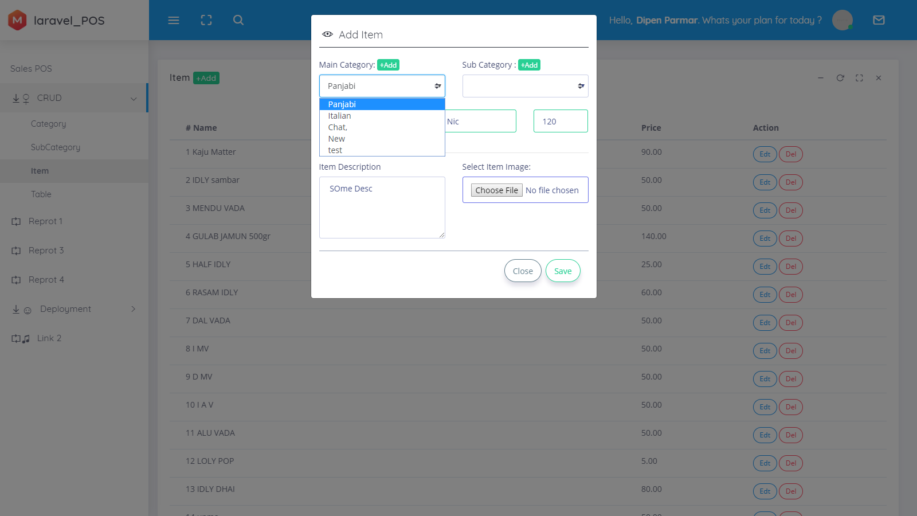

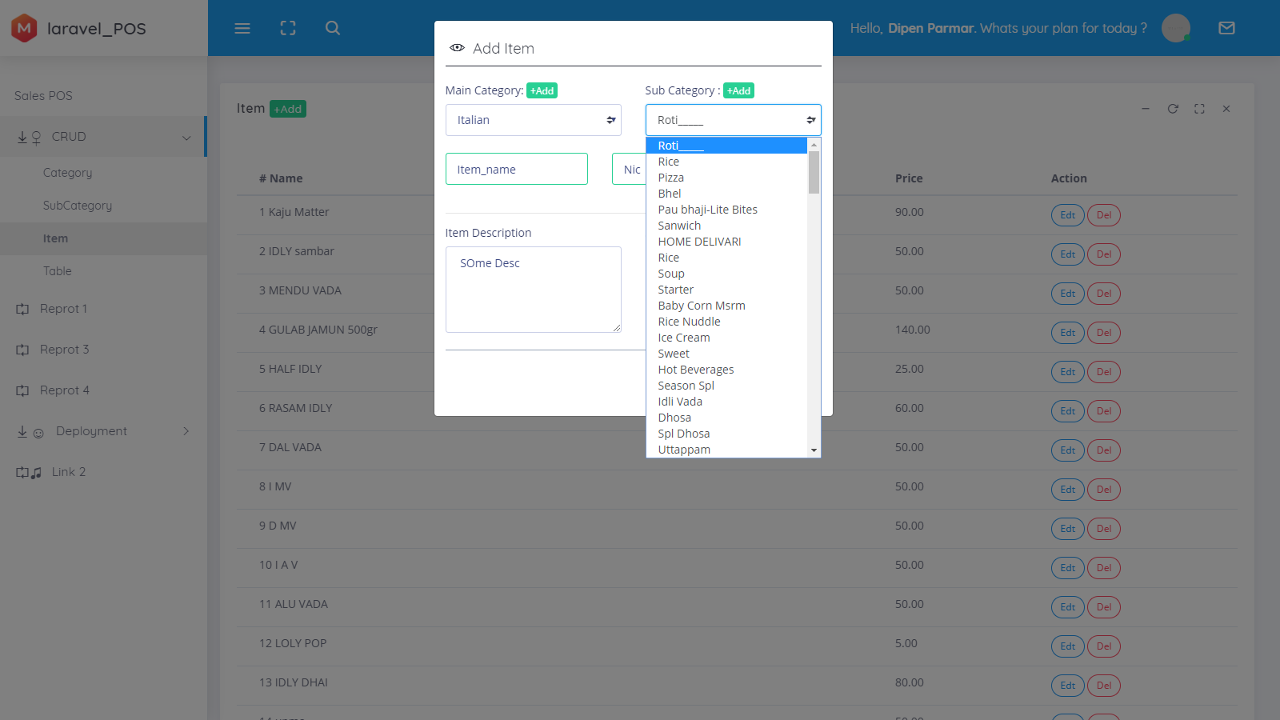

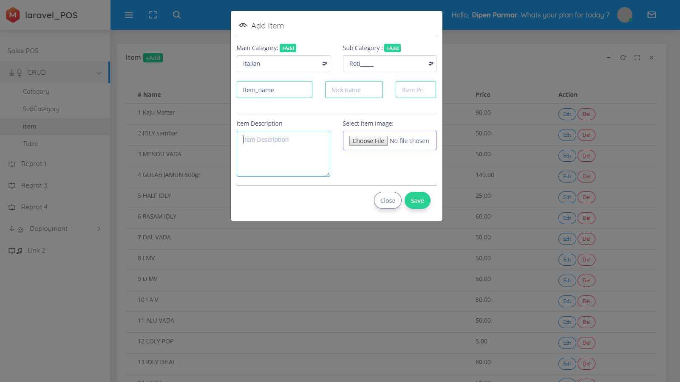

DATA DICTIONARY
Data dictionary: is a file or a set of files that contains a database's metadata. The data dictionary contains records about other objects in the database, such as data ownership, data relationships to other objects, and other data.
The data dictionary is a crucial component of any relational database. Ironically, because of its importance, it is invisible to most database users. Typically, only database administrators interact with the data dictionary.

In a relational database, the metadata in the data dictionary includes the following:
- Names of all tables in the database and their owners
- Names of all indexes and the columns to which the tables in those indexes relate
- Constraints defined on tables, including primary keys, foreign-key relationships to other tables, and not-null constraints

For most relational database management systems (RDBMS), the database management system software needs the data dictionary to access the data within a database. For example, the Oracle DB software has to read and write to an Oracle DB. However, it can only do this via the data dictionary created for that particular database.

Src: https://www.techopedia.com/definition/27752/data-dictionary

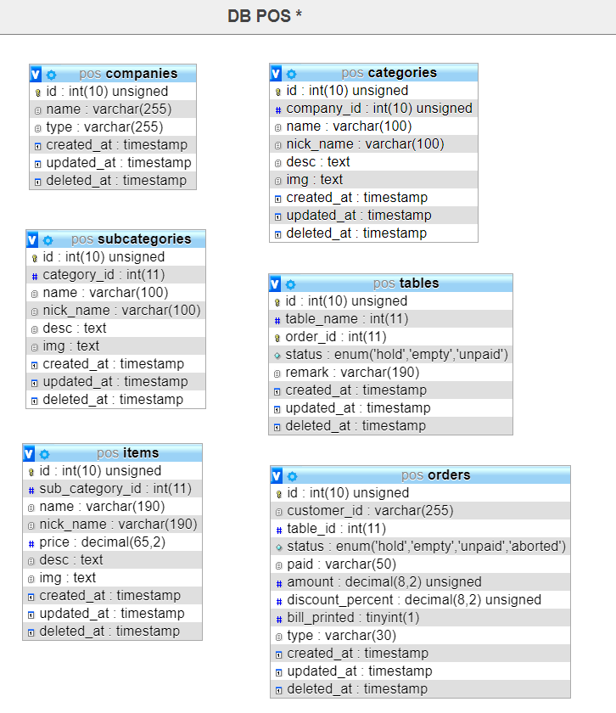

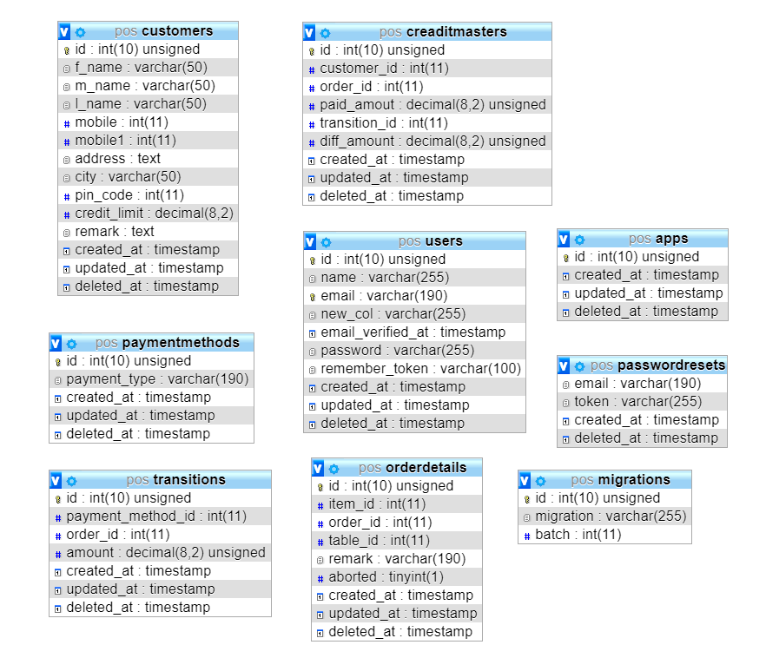

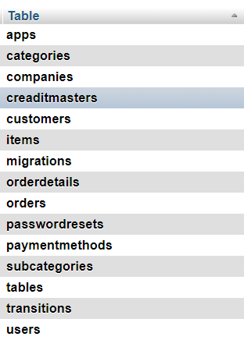
DATA FLOW DIAGRAM (DFD)

A data flow diagram shows the way information flows through a process or system. It includes data inputs and outputs, data stores, and the various sub processes the data moves through. DFDs are built using standardized symbols and notation to describe various entities and their relationships.

Data flow diagrams visually represent systems and processes that would be hard to describe in a chunk of text. You can use these diagrams to map out an existing system and make it better or to plan out a new system for implementation. Visualizing each element makes it easy to identify inefficiencies and produce the best possible system.

Physical and logical data flow diagrams

Before actually creating your data flow diagram, you’ll need to determine whether a physical or logical DFD best suits your needs. If you’re new to data flow diagrams, don’t worry—the distinction is pretty straightforward.

Logical data flow diagrams focus on what happens in a particular information flow: what information is being transmitted, what entities are receiving that info, what general processes occur, etc. The processes described in a logical DFD are business activities—a logical DFD doesn’t delve into the technical aspects of a process or system. Non-technical employees should be able to understand these diagrams.

Physical data flow diagrams focus on how things happen in an information flow. These diagrams specify the software, hardware, files, and people involved in an information flow. A detailed physical data flow diagram can facilitate the development of the code needed to implement a data system.
Symbols and Notations Used in DFDs
Two common systems of symbols are named after their creators:
- Yourdon and Coad
- Yourdon and DeMarco
- Gane and Sarson
One main difference in their symbols is that Yourdon-Coad and Yourdon-DeMarco use circles for processes, while Gane and Sarson use rectangles with rounded corners, sometimes called lozenges. There are other symbol variations in use as well, so the important thing to keep in mind is to be clear and consistent in the shapes and notations you use to communicate and collaborate with others.
Using any convention’s DFD rules or guidelines, the symbols depict the four components of data flow diagrams.
- External entity: an outside system that sends or receives data, communicating with the system being diagrammed. They are the sources and destinations of information entering or leaving the system. They might be an outside organization or person, a computer system or a business system. They are also known as terminators, sources and sinks or actors. They are typically drawn on the edges of the diagram.
- Process: any process that changes the data, producing an output. It might perform computations, or sort data based on logic, or direct the data flow based on business rules. A short label is used to describe the process, such as “Submit payment.”
- Data store: files or repositories that hold information for later use, such as a database table or a membership form. Each data store receives a simple label, such as “Orders.”

- Data flow: the route that data takes between the external entities, processes and data stores. It portrays the interface between the other components and is shown with arrows, typically labeled with a short data name, like “Billing details.”
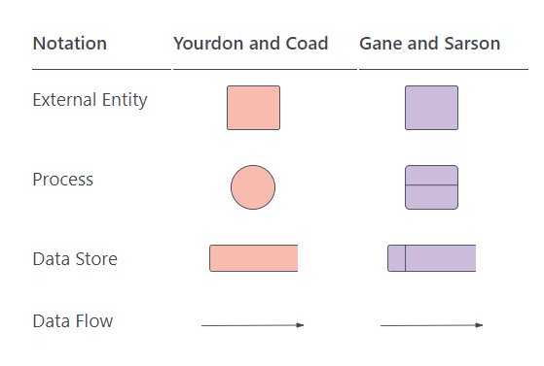

DFD rules and tips
- Each process should have at least one input and an output.
- Each data store should have at least one data flow in and one data flow out.
- Data stored in a system must go through a process.
- All processes in a DFD go to another process or a data store.

Src: https://www.lucidchart.com/pages/data-flow-diagram
Src: https://www.lucidchart.com/blog/data-flow-diagram-tutorial

Data flow diagram Restaurant Management System

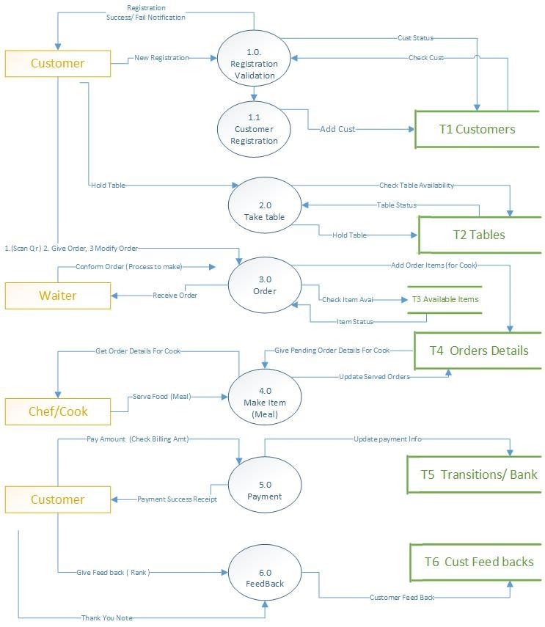

E-R DIAGRAM

An Entity Relationship (ER) Diagram is a type of flowchart that illustrates how “entities” such as people, objects or concepts relate to each other within a system. ER Diagrams are most often used to design or debug relational databases in the fields of software engineering, business information systems, education and research. Also known as ERDs or ER Models, they use a defined set of symbols such as rectangles, diamonds, ovals and connecting lines to depict the interconnectedness of entities, relationships and their attributes. They mirror grammatical structure, with entities as nouns and relationships as verbs.

ER diagrams are related to data structure diagrams (DSDs), which focus on the relationships of elements within entities instead of relationships between entities themselves. ER diagrams also are often used in conjunction with data flow diagrams (DFDs), which map out the flow of information for processes or systems.

Uses of entity relationship diagrams
- Database design: ER diagrams are used to model and design relational databases, in terms of logic and business rules (in a logical data model) and in terms of the specific technology to be implemented (in a physical data model.) In software engineering, an ER diagram is often an initial step in determining requirements for an information systems project. It’s also later used to model a particular database or databases. A relational database has an equivalent relational table and can potentially be expressed that way as needed.
- Database troubleshooting: ER diagrams are used to analyze existing databases to find and resolve problems in logic or deployment. Drawing the diagram should reveal where it’s going wrong.

- Business information systems: The diagrams are used to design or analyze relational databases used in business processes. Any business process that uses fielded data involving entities, actions and interplay can potentially benefit from a relational database. It can streamline processes, uncover information more easily and improve results.
- Business process re-engineering (BPR): ER diagrams help in analyzing databases used in business process re-engineering and in modeling a new database setup.
- Education: Databases are today’s method of storing relational information for educational purposes and later retrieval, so ER Diagrams can be valuable in planning those data structures.
- Research: Since so much research focuses on structured data, ER diagrams can play a key role in setting up useful databases to analyze the data.

The component’s and features of an ER Diagram
ER Diagrams are composed of entities, relationships and attributes. They also depict cardinality, which defines relationships in terms of numbers. Here’s a glossary:

Entity:

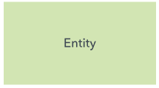
A definable thing—such as a person, object, concept or event—that can have data stored about it. Think of entities as nouns. Examples: a customer, student, car or product. Typically shown as a rectangle.

Entity type:
A group of definable things, such as students or athletes, whereas the entity would be the specific student or athlete. Other examples: customers, cars or products.
Entity set:
Same as an entity type, but defined at a particular point in time, such as students enrolled in a class on the first day. Other examples: Customers who purchased last month, cars currently registered in Florida. A related term is instance, in which the specific person or car would be an instance of the entity set.
Entity categories:
Entities are categorized as strong, weak or associative. A strong entity can be defined solely by its own attributes, while a weak entity cannot. An associative entity associates entities (or elements) within an entity set.
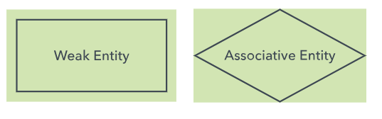
Entity keys: Refers to an attribute that uniquely defines an entity in an entity set. Entity keys can be super, candidate or primary. Super key: A set of attributes (one or more) that together define an entity in an entity set. Candidate key: A minimal super key, meaning it has the least possible number of attributes to still be a super key. An entity set may have more than one candidate key. Primary key: A candidate key chosen by the database designer to uniquely identify the entity set. Foreign key: Identifies the relationship between entities.

Relationship
How entities act upon each other or are associated with each other. Think of relationships as verbs. For example, the named student might register for a course. The two entities would be the student and the course, and the relationship depicted is the act of enrolling, connecting the two entities in that way. Relationships are typically shown as diamonds or labels directly on the connecting lines.
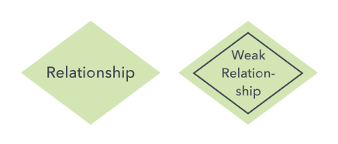
Recursive relationship: The same entity participates more than once in the relationship.

Attribute
A property or characteristic of an entity. Often shown as an oval or circle.

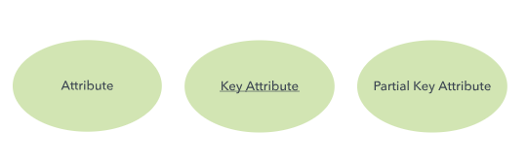

Descriptive attribute: A property or characteristic of a relationship (versus of an entity.)

Attribute categories: Attributes are categorized as simple, composite, derived, as well as single-value or multi-value. Simple: Means the attribute value is atomic and can’t be further divided, such as a phone number. Composite: Sub-attributes spring from an attribute. Derived: Attributed is calculated or otherwise derived from another attribute, such as age from a birthdate.
Multi-value: More than one attribute value is denoted, such as multiple phone numbers for a person.

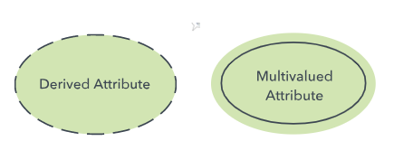
Single-value: Just one attribute value. The types can be combined, such as: simple single-value attributes or composite multi-value attributes.
Cardinality
Defines the numerical attributes of the relationship between two entities or entity sets. The three main cardinal relationships are one-to-one, one-to-many, and many-many. A one-to-one example would be one student associated with one mailing address. A one-to-many example (or many-to-one, depending on the relationship direction): One student registers for multiple courses, but all those courses have a single line back to that one student. Many-to-many example: Students as a group are associated with multiple faculty members, and faculty members in turn are associated with multiple students.
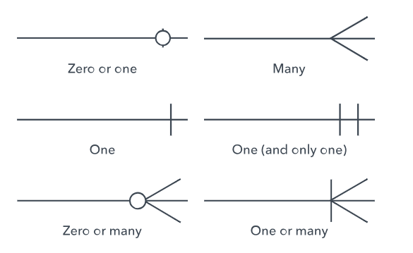
Cardinality views: Cardinality can be shown as look-across or same-side, depending on where the symbols are shown.
Cardinality constraints: The minimum or maximum numbers that apply to a relationship.

Scr: https://www.lucidchart.com/pages/er-diagrams?a=0

ERD symbols and notations
There are several notation systems, which are similar but vary in a few specifics.
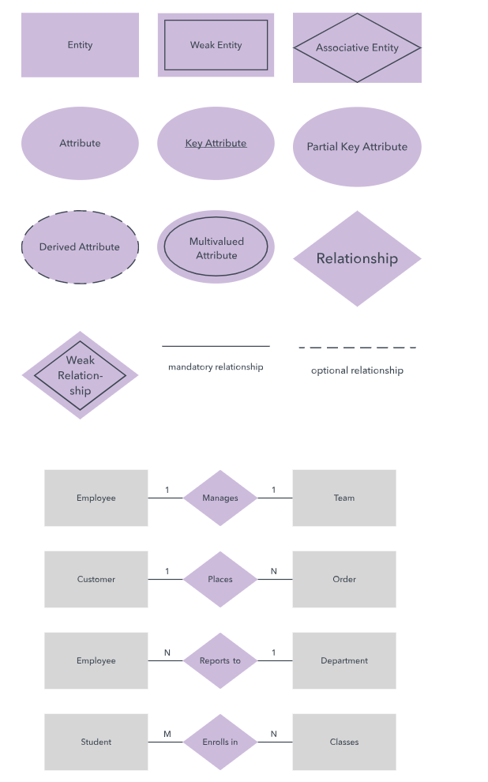
- E-R Diagram for Restaurant management system

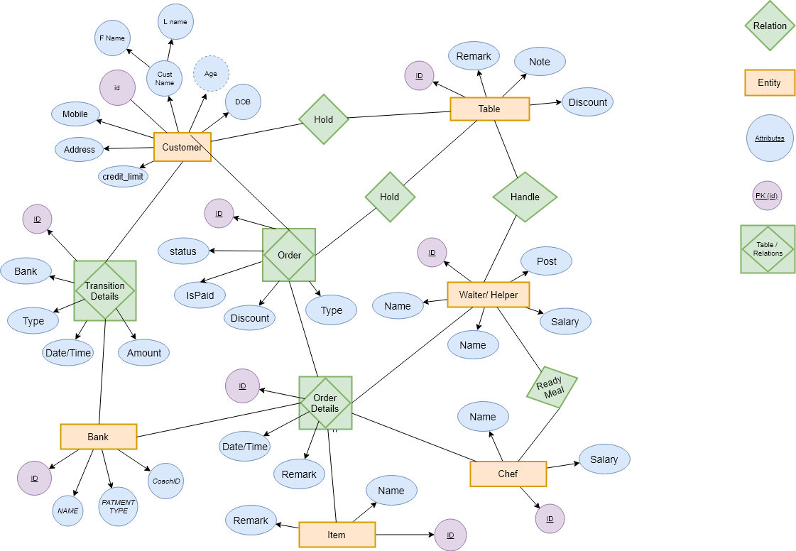

DATABASE STRUCTURE

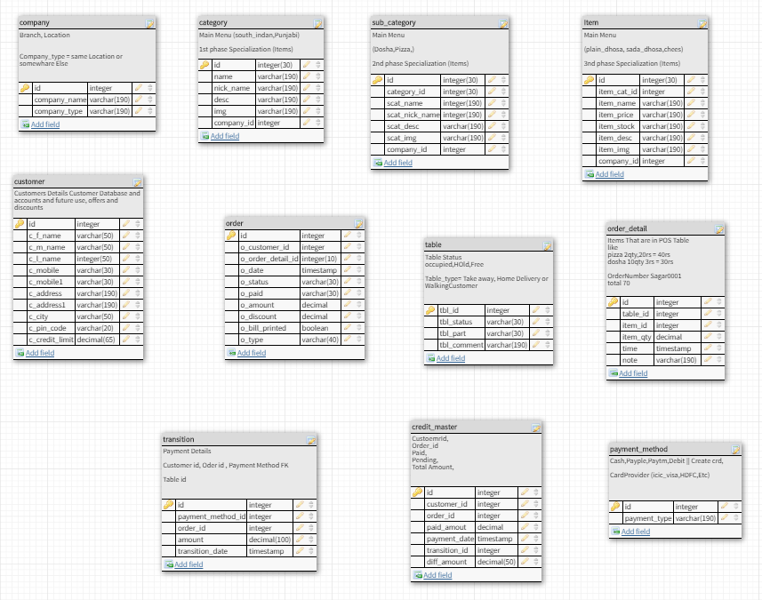

ERRORS AND SOLUTIONS

________________ Date:: 4.Nov.2017 ________________
----- In Laravel, how do I retrieve a random user_id from the Users table for Model Factory seeding data generation?
$user_id = App\User::all()->random()->id,
'user_id' => User::where('username', 'like', 'test@user.com')->get()->random()->user_id
Src: https://stackoverflow.com/questions/44102483/in-laravel-how-do-i-retrieve-a-random-user-id-from-the-users-table-for-model-fa/44102531

---- ----------------------------- php artisan make:controller Command not working
Error: RuntimeException : Unable to detect application namespace.
Src: https://stackoverflow.com/questions/31903442/laravel-5-unable-to-detect-application-namespace
"require": {
"php": ">=5.5.9",
"laravel/framework": "5.1.*",
}
Removed the comma so it looked like this:
"require": {
"php": ">=5.5.9",
"laravel/framework": "5.1.*"
}

________________ Date:: 7.Nov.2017 ________________
------ ( laravel check if file exists in public ) Determining If a File Exists in Laravel 5
@if(file_exists( public_path().'/images/photos/account/'.Auth::user()->account_id.'.png' ))
<img src="/images/photos/account/{{Auth::user()->account_id}}.png" alt="">
@else
<img src="/images/photos/account/default.png" alt="">
@endif

Src: 1. https://stackoverflow.com/questions/34028575/determining-if-a-file-exists-in-laravel-5
2. https://itsolutionstuff.com/post/how-to-check-if-file-exists-or-not-in-laravel-5example.html

------- (get file name from glob php) How to return just file name using glob() in php
Use basename()
echo basename($image);
You can also remove the extension like this:
echo basename($image, '.php');
Scr: https://stackoverflow.com/questions/14366928/how-to-return-just-file-name-using-glob-in-php

------- ( how to get list of files exists in folder laravel) In Laravel 5, how can I obtain a list of all files in a public folder?
<?php
foreach (glob("/location/for/public/images/*.png") as $filename) {
echo "$filename size " . filesize($filename) . "\n";
}
?>

Src: https://stackoverflow.com/questions/31316543/in-laravel-5-how-can-i-obtain-a-list-of-all-files-in-a-public-folder
Src: https://stackoverflow.com/questions/2395882/how-to-remove-extension-from-string-only-real-extension

________________ Date:: 12.Nov.2017 ________________
------ (How to setup ajax laravel csrf ) Laravel csrf token mismatch for ajax POST Request
n header
<meta name="csrf-token" content="{{ csrf_token() }}" />
In script
<script type="text/javascript">
$.ajaxSetup({
headers: {
'X-CSRF-TOKEN': $('meta[name="csrf-token"]').attr('content')
}
});
</script>

------ (trigger click event on page load jquery) How to trigger click on page load?
$(function(){

$(selector).click();

});

OR

$(document).ready(function(){
$("#id").trigger("click");
});

Src: https://stackoverflow.com/questions/2060019/how-to-trigger-click-on-page-load

________________ Date:: 14.Nov.2017 ________________

-------(laravel find by id and convert to json) Serializing Models & Collections , Serializing To JSON And Serializing To Arrays
$users = App\User::all();
return $user->toJson();
return $users->toArray();
Src: https://laravel.com/docs/5.7/eloquent-serialization

--------( php array to javascript object) convert php associative array into javascript object

var words = <?php echo json_encode($wordsArray) ?>;// don't use quotes
$.each(words, function(key, value) {
console.log('stuff : ' + key + ", " + value);
});
// Echo unescaped content; 5.0 feature{!! $var !!}

Src: https://stackoverflow.com/questions/21153805/convert-php-associative-array-into-javascript-object

----------------( html set data attribute ) How to set data attributes in HTML elements
HTML
<div id="mydiv" data-myval="10"></div>
JS
var a = $('#mydiv').data('myval'); //getter

$('#mydiv').data('myval',20); //setter

Src: https://stackoverflow.com/questions/13524107/how-to-set-data-attributes-in-html-elements

----------------( assign or copy one object to another object in jquery ) Cloning an object in javascript
var objY = $.parseJSON(JSON.stringify(data));
var objX = $.parseJSON(JSON.stringify(data));
Src: https://stackoverflow.com/questions/5364650/cloning-an-object-in-javascript

________________ Date:: 16.Nov.2017 ________________

----------------( jquery dynamic loaded data click event not working ) Click Event is not Working When Data loads Dynamic in jquery
Use this:
$('body').on('click','.favourate_dextop',function(e){
//code
});
Instead of
$('.favourate_dextop').click(function(e){
//code
});

---------------( php object to array ) Convert an object to associative array in PHP

$myArray = json_decode(json_encode($object), true);
Src: https://www.geeksforgeeks.org/convert-an-object-to-associative-array-in-php/

----------------( laravel get url except domain name ) Accessing The Current URL in Laravel

// Get the current URL without the query string...
echo url()->current();
// Get the current URL including the query string...
echo url()->full();
// Get the full URL for the previous request...
echo url()->previous();
Src: https://laracasts.com/discuss/channels/laravel/getting-the-url-after-domain-in-laravel?page=1
OR
https://laravel.com/docs/5.7/urls

---------------(laravel get all tables ) How to fetch the tables list in database in Laravel 5.1

To list out the tables in database you can do
$tables = DB::select('SHOW TABLES');
foreach($tables as $table)
{
echo $table->Tables_in_db_name;
}

Src: https://stackoverflow.com/questions/33478988/how-to-fetch-the-tables-list-in-database-in-laravel-5-1

---------------(laravel check session exists) Check if session key exists in Laravel 5.1?

if(Session::has('your_key')){
return $next($request);
}

Src: https://stackoverflow.com/questions/31111392/check-if-session-key-exists-in-laravel-5-1

---------------(laravel update query builder ) Laravel Update Query

DB::table('users')
->where('email', $userEmail) // find your user by their email
->limit(1) // optional - to ensure only one record is updated.
->update(array('member_type' => $plan)); // update the record in the DB.

Src: https://stackoverflow.com/questions/27248753/laravel-update-query

________________ Date:: 17.Nov.2017 ________________

---------------( php late static binding ) How to get class name from static child method

<?php
class MyParent {

public static function tellSomething() {
return __CLASS__;
}
}

class MyChild extends MyParent {

}

echo MyChild::tellSomething();

Src: https://stackoverflow.com/questions/6521342/how-to-get-class-name-from-static-child-method

________________ Date:: 19.Nov.2017 ________________

---------------( call function by their name with function php ) How to call PHP function from string stored in a Variable

$functionName() or call_user_func($functionName)
My Ans:
public function href($fun=’index’){
return $this->$fun();
}

Src: https://stackoverflow.com/questions/1005857/how-to-call-php-function-from-string-stored-in-a-variable

---------------(get html data values jquery )
Src: https://stackoverflow.com/questions/5309926/how-to-get-the-data-id-attribute

To get the contents of the attribute data-id (like in <a data-id="123">link</a>) you have to use
$(this).attr("data-id") // will return the string "123"
or .data() (if you use newer jQuery >= 1.4.3)
$(this).data("id") // will return the number 123

________________ Date:: 20.Nov.2017 ________________

---------------( laravel post ajax request token set ) Laravel csrf token mismatch for ajax POST Request

$.ajax({
type:'POST',
url:'/pos/active_table_select/'+table_id,
data:{id:table_id},
headers: {'X-CSRF-TOKEN': $('meta[name="csrf-token"]').attr('content')},
success:function(response){
// console.log(response);
// Append Updated table_select_palette after Active Table selected
$('#section_table_select_palette div').empty().append(response);
}
});
Src: https://stackoverflow.com/questions/32738763/laravel-csrf-token-mismatch-for-ajax-post-request

---------------(search from html table by input text jquery ) How TO - Filter/Search Table

<input type="text" id="myInput" onkeyup="myFunction()" placeholder="Search for names..">
function myFunction() {
// Declare variables
var input, filter, table, tr, td, i;
input = document.getElementById("myInput");
filter = input.value.toUpperCase();
table = document.getElementById("myTable");
tr = table.getElementsByTagName("tr");
// Loop through all table rows, and hide those who don't match the search query
for (i = 0; i < tr.length; i++) {
td = tr[i].getElementsByTagName("td")[0];
if (td) {
if (td.innerHTML.toUpperCase().indexOf(filter) > -1) {
tr[i].style.display = "";
} else {
tr[i].style.display = "none";
}
}
}
}

Src: https://www.w3schools.com/howto/howto_js_filter_table.asp
https://stackoverflow.com/questions/12433304/live-search-through-table-rows

---------------( table text selectable disabled by mouse ) How to disable text selection highlighting?

-webkit-user-select: none;
-moz-user-select: none;
-ms-user-select: none;
-o-user-select: none;
user-select: none;

Src: https://stackoverflow.com/questions/826782/how-to-disable-text-selection-highlighting

________________ Date:: 21.Nov.2017 ________________

---------------(laravel where more then one value eloquent) How to Create Multiple Where Clause Query Using Laravel Eloquent?

Model::where('column_1','=','value_1')->where('column_2 ','=','value_2')->get();OR
// If you are looking for equal value then no need to add =
Model::where('column_1','value_1')->where('column_2','value_2')->get();
Model::where(['column_1' => 'value_1','column_2' => 'value_2'])->get();

OR

$this->where('email', $email)->where('password', $password)
is returning a Builder object which you could use to append more where filters etc.
To get the result you need:
$userRecord = $this->where('email', $email)->where('password', $password)->first();

Src: https://stackoverflow.com/questions/19325312/how-to-create-multiple-where-clause-query-using-laravel-eloquent
https://stackoverflow.com/questions/20454857/laravel-select-where-and-where-condition

________________ Date:: 22.Nov.2017 ________________

---------------(laravel alter table add field migration ) Add a new column to existing table in a migration

You can add new columns within the initial Schema::create method like this:

Schema::create('users', function($table) {
$table->integer("paied");
$table->string("title");
$table->text("description");
$table->timestamps();
});

If you have already created a table you can add additional columns to that table by creating a new migration and using the Schema::table method:

Schema::table('users', function($table) {
$table->string("title");
$table->text("description");
$table->timestamps();
});

Src: https://stackoverflow.com/questions/16791613/add-a-new-column-to-existing-table-in-a-migration

________________ Date:: 25.Nov.2017 ________________

---------------( jquery keyboard combine two shortcut key event set ) jquery: keypress, ctrl+c (or some combo like that)

$(document).keydown(function(e) {
if(e.key == "c" && e.ctrlKey) {
console.log('ctrl+c was pressed');
}
});

Src: https://stackoverflow.com/questions/4604057/jquery-keypress-ctrlc-or-some-combo-like-that

---------------( Multi key press event handler with function keys jquery ) Can jQuery .keypress() detect more than one key at the same time?

$(document).bind('keypress', function(event) {
if( event.which === 65 && event.shiftKey ) {
alert('you pressed SHIFT+A');
}
});

Jsfiddle demo.

Other propertys are:
- event.ctrlKey
- event.altKey
- event.metaKey

Src: https://stackoverflow.com/questions/4954403/can-jquery-keypress-detect-more-than-one-key-at-the-same-time

---------------(jquery use f1 f2 key events ) Handling key-press events (F1-F12) using JavaScript and jQuery, cross-browser

$(function(){
//Yes! use keydown 'cus some keys is fired only in this trigger,
//such arrows keys
$("body").keydown(function(e){
//well you need keep on mind that your browser use some keys
//to call some function, so we'll prevent this
e.preventDefault();

//now we caught the key code, yabadabadoo!!
var keyCode = e.keyCode || e.which;

//your keyCode contains the key code, F1 to F12
//is among 112 and 123. Just it.
console.log(keyCode);
});
});

Src: https://stackoverflow.com/questions/424407/handling-key-press-events-f1-f12-using-javascript-and-jquery-cross-browser

________________ Date:: 1.Dec.2017 ________________

---------------(print page with javascript) Window print() Method
window.print();
Src: https://www.w3schools.com/jsref/met_win_print.asp

________________ Date:: 7.Dec.2017 ________________

---------------( laravel create model instance dynamically ) Dynamically create Class object based on string

$className = 'App\\Http\\API\\' . $source;

$controller = new $className;

return $controller->index();

OR

$className = __NAMESPACE__ . '\\' . $source;

$controller = new $className;

return $controller->index();

OR

class Factory {
function __construct ( $namespace = '' ) {
$this->namespace = $namespace;
}

public function make ( $source ) {
$name = $this->namespace . '\\' . $source;

if ( class_exists( $name ) ) {
return new $name();
}
}
}

$factory = new Factory( __NAMESPACE__ );

$controller = $factory->make( $source );

Src: https://stackoverflow.com/questions/33422627/laravel-5-1-dynamically-create-class-object-based-on-string/33422826

---------------(get controller name in laravel without namespace) PHP get class name without namespace

public function getName() {
$path = explode('\\', __CLASS__);
return array_pop($path);
}

Src: https://coderwall.com/p/cpxxxw/php-get-class-name-without-namespace

________________ Date:: 9.Dec.2017 ________________

---------------(laravel check available variables in blade page) List all registered variables inside a Laravel view

Use the dd helper:
{{ dd(get_defined_vars()) }}
Read more: https://laravel.com/docs/5.4/helpers#method-dd
Update (thx, @JoeCoder): you can further cutdown on the "useless" variables by doing:
{{ dd(get_defined_vars()['__data']) }}
Src: https://stackoverflow.com/questions/29146879/list-all-registered-variables-inside-a-laravel-view

---------------(laravel can we create and use methods in view) How to call a controller function inside a view in laravel 5

For accessing a method of a Controller from a view page you need to give the full path of that controller in your blade page.
use App\Http\Controllers\AdminAfterAuth;
$admin_dtls = AdminAfterAuth::globAdmin();
Here AdminAfterAuth is the controller class name and globAdmin is the method name.
Now in your controller declare the method statically.
public static function globAdmin(){
$admin_val = AdminLogin::where('id',session('admin_id'))->get();
return $admin_val;
}

Src: https://stackoverflow.com/questions/35332784/how-to-call-a-controller-function-inside-a-view-in-laravel-5

---------------(How to Get the Value of Selected Option in a Select Box Using jQuery) How to get value from r.fn.init (JQuery selector context)

HTML DOM textContent Property
var x = document.getElementById("myBtn").textContent;

<tr>
<td>
<button type="button" class="some-button"></button>
</td>
<td>
<span class="sibbling">100</span>
</td>
</tr>

$(function(){
$('.some-button').click(function(){
var id = $(this).closest('tr').find('.sibbling').text();
// .closest() gets the closest tr parent .
// .find() finds the element with class 'sibbling' inside that `tr`
// .text() gets the text inside the element.
});
});

Src: https://stackoverflow.com/questions/48110198/how-to-get-value-from-r-fn-init-jquery-selector-context?noredirect=1&lq=1
https://www.w3schools.com/jsref/prop_node_textcontent.asp

---------------( jquery copy object to new object ) What is the most efficient way to deep clone an object in JavaScript?

JavaScript objects, you would do:
// Shallow copy
var newObject = jQuery.extend({}, oldObject);

// Deep copy
var newObject = jQuery.extend(true, {}, oldObject);

Src: https://stackoverflow.com/questions/122102/what-is-the-most-efficient-way-to-deep-clone-an-object-in-javascript

---------------(html a href target blank with width height ) Opening new window in HTML for target=“_blank”
<a href="http://www.facebook.com/sharer" onclick="window.open(this.href, 'mywin',
'left=20,top=20,width=500,height=500,toolbar=1,resizable=0'); return false;" >Share this</a>
OR
<a href="facebook.com/sharer" target="_blank" >Share this</a>
Src: https://stackoverflow.com/questions/2541392/opening-new-window-in-html-for-target-blank

________________ Date:: 20.Dec.2017 ________________

---------------(laravel get resource directories) Customizing the Laravel View Path -
'paths' => [
resource_path('views'),
app_path('views'),
],

Src: https://laravel-news.com/laravel-view-path

---------------( php get last element of array ) PHP end() Function
$people = array("Peter", "Joe", "Glenn", "Cleveland");
echo current($people) . "<br>";
echo end($people);
Src: https://www.w3schools.com/php/func_array_end.asp

